|  |  |  |
| --- | --- | --- |
| **University of Petra** | ***شعار جامعة البترا5 -*** | ***C:\Documents and Settings\jsaqqa\Local Settings\Temporary Internet Files\Content.Outlook\ZIA6H205\شعار جامعة البترا - عشرون عاما 1.jpg*** |
| **Faculty of Information Technology** | **كلية تكنولوجيا المعلومات** |

**Graduation Project Final Document**

**“Machine Learning: Convolutional Neural Networks”**

**“Smart Guide”**

**Prepared By:**

**Walaa Abu Mailish 201520398  
Raghad Rabah 201511102  
Leen Attari 201510496  
Aya Alatoom 201530064**

**Supervised By:**

**Dr. Ahmad Shubeita**

**Date:**

**2018/2019**

**First Semester**

**Acknowledgements**:

* Dr. Ahmad Shubeita
* Dr. Abdelkareem Albanna
* Dr. Izzedeen Matar
* Mr. Mohannad Malhis

**Abstract**

Smart Guide is a project of an application that helps with providing information of historical places to the user. It is implemented only to serve on android mobile phones, with many interesting features including image search, text search and many more. It only covers the most known historical places in Jordan. One of the main goals of our project is to increase the efficiency of tourism in Jordan. In addition to that, increase people’s knowledge in these valuable places.

**Table of Contents**

[Chapter One 11](#_Toc396181)

[Project Initiating 11](#_Toc396182)

[1. Project Initiation 12](#_Toc396183)

[1.1 Problem Definition 12](#_Toc396184)

[1.2 Current/Existing Systems: 12](#_Toc396185)

[1.2.1 Tour Guides (Current system) 12](#_Toc396186)

[1.2.2 Asfar (existing system): 13](#_Toc396187)

[1.2.3 Field Trip (existing system): 13](#_Toc396188)

[1.2.3 Rick Steves Audio Europe ™ (existing system): 14](#_Toc396189)

[1.3 Literature Review: 15](#_Toc396190)

[1.3.1 Introduction 15](#_Toc396191)

[1.3.2 Growth of tourism 15](#_Toc396192)

[1.3.3 Tourism in Jordan 16](#_Toc396193)

[1.3.4 Technology’s role in tourism 17](#_Toc396194)

[1.3.5 Diffusion of Internet Technology in the Tourism Sector: 20](#_Toc396195)

[1.3.6 The Role of Mobile Technology in Tourism 21](#_Toc396196)

[1.3.7 Conclusion: 27](#_Toc396197)

[1.4 Project objectives: 27](#_Toc396198)

[1.5 Stakeholders list: 28](#_Toc396199)

[1.6 Scope excluded and Project constraints: 28](#_Toc396200)

[1.6.1 Scope excluded: 28](#_Toc396201)

[1.6.2 Project constraints: 29](#_Toc396202)

[1.7 Proposed Scope and Process Model: 29](#_Toc396203)

[1.7.1 Proposed scope: 29](#_Toc396204)

[1.7.2 Process model 30](#_Toc396205)

[Chapter two 31](#_Toc396206)

[Planning and requirements 31](#_Toc396207)

[2. Planning and Requirements 32](#_Toc396208)

[2.1 Planning 32](#_Toc396209)

[2.1.1 Scope Initiation (WBS) 32](#_Toc396210)

[2.1.2 Gantt chart 34](#_Toc396211)

[2.1.3 Resource Planning Scheduling and Resources Distribution 37](#_Toc396212)

[2.1.4 System Development Requirements: 37](#_Toc396213)

[2.1.5 Cost estimating and budgeting 38](#_Toc396214)

[2.1.6 Risk List: 40](#_Toc396215)

[2.2 Requirements 40](#_Toc396216)

[2.2.1 Elicitation Techniques 40](#_Toc396217)

[2.2.1.1 Brainstorming: 40](#_Toc396218)

[2.2.1.2 Questionnaire: 40](#_Toc396219)

[2.2.2 Use Case specification 41](#_Toc396220)

[2.2.3 Domain Object Diagram 50](#_Toc396221)

[Chapter Three 41](#_Toc396222)

[Project analysis and Design 41](#_Toc396223)

[3. Project Analysis and Design 42](#_Toc396224)

[3.1 Use Case Diagram 42](#_Toc396225)

[3.2 Activity Diagram 43](#_Toc396226)

[3.2.1 Sign up activity. 43](#_Toc396227)

[3.2.2 Login activity. 44](#_Toc396228)

[3.2.3 Picture searching activity. 45](#_Toc396229)

[3.2.4 Add new places activity. 46](#_Toc396230)

[3.2.5 Update places activity. 47](#_Toc396231)

[3.2.6 Delete places activity. 48](#_Toc396232)

[3.2.7 Preview places information activity. 49](#_Toc396233)

[3.2.8 Rate place activity. 50](#_Toc396234)

[3.3 Sequence Diagrams: 51](#_Toc396235)

[3.3.1 Add place. 51](#_Toc396236)

[3.3.2 Delete place. 52](#_Toc396237)

[3.3.3 Login. 53](#_Toc396238)

[3.3.4 Preview info. 54](#_Toc396239)

[3.3.5 Rate place. 55](#_Toc396240)

[3.3.5 Sign up 56](#_Toc396241)

[3.3.6 Take picture. 57](#_Toc396242)

[3.3.7 Update place. 58](#_Toc396243)

[3.4 State Chart Diagram 59](#_Toc396244)

[3.4.1 Place Info State chart 59](#_Toc396245)

[3.4.2 Account state chart. 59](#_Toc396246)

[3.4.3 Picture state chart. 59](#_Toc396247)

[3.4.4 Rate state chart. 60](#_Toc396248)

[3.5 Design Class Diagram: 60](#_Toc396249)

[3.6 Components Diagram: 61](#_Toc396250)

[3.7 Deployment Diagram. 61](#_Toc396251)

[3.8 Output & Input Design (Screens): 62](#_Toc396252)

[3.8.1 Login 62](#_Toc396253)

[3.8.2 Sign up 63](#_Toc396254)

[3.8.3 Picture searching 64](#_Toc396255)

[3.8.4 Menu view 65](#_Toc396256)

[3.8.5 Output screen 66](#_Toc396257)

[3.8.6 Admin interface (update, delete, add place). 67](#_Toc396258)

[Chapter Four 69](#_Toc396259)

[Implementations and testing 69](#_Toc396260)

[4. Implementation and Testing 70](#_Toc396261)

[4.1 Database Mapping (Schema Diagram): 70](#_Toc396262)

[4.2 Tables Descriptions: 71](#_Toc396263)

[4.3 Architecture/technology Description: 72](#_Toc396264)

[4.4 Algorithm for major functions: 76](#_Toc396265)

[4.4.1 Add Place Algorithm 76](#_Toc396266)

[4.4.2 Signup Algorithm 77](#_Toc396267)

[4.4.3 Login Algorithm 77](#_Toc396268)

[4.4.4 Search for place(Text) Algorithm 78](#_Toc396269)

[4.4.5 Search for place(Image) Algorithm 78](#_Toc396270)

[4.4.6 Update Place Algorithm 79](#_Toc396271)

[4.4.7 Delete Place Algorithm 79](#_Toc396272)

[4.5 Sample code for main functions: 80](#_Toc396273)

[4.5.1 Login Function 80](#_Toc396274)

[4.5.2 Signup Function 81](#_Toc396275)

[4.5.3 Add Place Function 82](#_Toc396276)

[4.5.4 Update Place Function 82](#_Toc396277)

[4.5.5 Delete Place Function 83](#_Toc396278)

[4.5.6 Search (TEXT) Function 83](#_Toc396279)

[4.5.7 Search (Image) Function 83](#_Toc396280)

[4.6Functional test cases: 85](#_Toc396281)

[4.6.1 Login function: 85](#_Toc396282)

[4.6.2 Sign up function: 85](#_Toc396283)

[4.6.3 Add Places: 86](#_Toc396284)

[4.6.4 Delete Places: 87](#_Toc396285)

[4.6.5 Update Places: 87](#_Toc396286)

[4.6.6 Search Place (Text): 88](#_Toc396287)

[4.6.7 Search Place (image): 88](#_Toc396288)

[Chapter Five 89](#_Toc396289)

[Conclusion and future improvements 89](#_Toc396290)

[5. Conclusion and Future Improvements 90](#_Toc396291)

[5.1 Conclusion: 90](#_Toc396292)

[5.2 Future improvements: 90](#_Toc396293)

[Appendix A Questionnaire analysis results a](#_Toc396294)

[References: 4](#_Toc396295)

**Table of Figures:**

[Figure 1:Asfar app logo 12](file:///C:\Users\walaa\Desktop\FinalDoc.docx#_Toc535405095)

[Figure 2:Field Trip app logo 13](file:///C:\Users\walaa\Desktop\FinalDoc.docx#_Toc535405096)

[Figure 3:Rick Steves Audio Europe ™app logo 13](file:///C:\Users\walaa\Desktop\FinalDoc.docx#_Toc535405097)

[Figure 4:The growth of the world tourism industry 15](#_Toc535405098)

[Figure 5:Proposed Scope 25](#_Toc535405099)

[Figure 6:Gantt Chart 29](#_Toc535405100)

[Figure 7:Gantt Chart 29](file:///C:\Users\walaa\Desktop\FinalDoc.docx#_Toc535405101)

[Figure 8:Gantt Chart 30](#_Toc535405102)

[Figure 9:Gantt Chart 30](#_Toc535405103)

[Figure 10:Resource Sheet 31](#_Toc535405104)

[Figure 11:Cash Flow 32](#_Toc535405105)

[Figure 12:Cost overruns 33](#_Toc535405106)

[Figure 13:Resource cost overview 33](#_Toc535405107)

[Figure 14:Doman Object Diagram 41](#_Toc535405108)

[Figure 15:Use case Diagram 41](#_Toc535405109)

[Figure 16:Sign up activity diagram 42](#_Toc535405110)

[Figure 17:Login activity diagram 43](#_Toc535405111)

[Figure 18:Picture searching activity diagram 44](#_Toc535405112)

[Figure 19:Add new place activity diagram 45](#_Toc535405113)

[Figure 20:Update activity diagram 46](#_Toc535405114)

[Figure 21:Delete place activity diagram 47](#_Toc535405115)

[Figure 22:preview places information activity diagram 48](#_Toc535405116)

[Figure 23:Rate place activity 49](#_Toc535405117)

[Figure 24:Add place sequence Diagram 50](#_Toc535405118)

[Figure 25: Delete sequence diagram 51](#_Toc535405119)

[Figure 26:Login sequence Diagram 52](#_Toc535405120)

[Figure 27:Preview Information about place 53](#_Toc535405121)

[Figure 28:Rate place sequence diagram 54](#_Toc535405122)

[Figure 29:Sign Up sequence Diagram 55](#_Toc535405123)

[Figure 30:Take picture sequence diagram 56](#_Toc535405124)

[Figure 31:Update place sequence Diagram 57](#_Toc535405125)

[Figure 32:PlaceInfo Statechart 58](#_Toc535405126)

[Figure 33:Account state chart 58](#_Toc535405127)

[Figure 34:Picture searching state chart 58](#_Toc535405128)

[Figure 35:Rate statechart 59](#_Toc535405129)

[Figure 36:Design class diagram 60](#_Toc535405130)

[Figure 37: Component Diagram 61](#_Toc535405131)

[Figure 38:Deployment Diagram 61](#_Toc535405132)

[Figure 39:Login Screen 62](#_Toc535405133)

[Figure 40:Sign Up screen 63](#_Toc535405134)

[Figure 41:Picture Searching screen 65](file:///C:\Users\walaa\Desktop\FinalDoc.docx#_Toc535405135)

[Figure 42:Menu View Screen 66](#_Toc535405136)

[Figure 43:output screen 67](#_Toc535405137)

[Figure 44:admin interface screen 68](file:///C:\Users\walaa\Desktop\FinalDoc.docx#_Toc535405138)

[Figure 45:manage places screen 69](#_Toc535405139)

[Figure 46: Database Mapping 70](#_Toc535405140)

[Figure 47: Database tables 70](#_Toc535405141)

[Figure 48: Tourist Table 71](#_Toc535405142)

[Figure 49: Admin Table 71](#_Toc535405143)

[Figure 50: Place Table 72](#_Toc535405144)

[Figure 51:System Architecture 73](#_Toc535405145)

[Figure 52:Login function 78](#_Toc535405146)

[Figure 53:Sign Up 78](#_Toc535405147)

[Figure 54:Add place 79](#_Toc535405148)

[Figure 55:Update place 79](#_Toc535405149)

[Figure 56:Delete Place 80](#_Toc535405150)

[Figure 57:Search for place by text 80](#_Toc535405151)

[Figure 58:Search for place by image(android) 80](#_Toc535405152)

[Figure 59:Search for place by image(Python) 81](#_Toc535405153)

[Figure 60: Questionnaire analysis a](#_Toc535405154)

[Figure 61: Questionnaire analysis a](#_Toc535405155)

[Figure 62: Questionnaire analysis b](#_Toc535405156)

[Figure 63: Questionnaire analysis b](#_Toc535405157)

[Figure 64: Questionnaire analysis 3](#_Toc535405158)

**List of Tables**

[Table 1:Technology's role in tourism 17](#_Toc535405159)

[Table 2: Stakeholders 23](#_Toc535405160)

[Table 3:WBS 26](#_Toc535405161)

[Table 4:WBS 27](file:///C:\Users\walaa\Desktop\FinalDoc.docx#_Toc535405162)

[Table 5:WBS 28](#_Toc535405163)

[Table 6:WBS 28](#_Toc535405164)

[Table 7:Resources 31](#_Toc535405165)

[Table 8:Cost of resources 32](#_Toc535405166)

[Table 9:Login Function test case 82](#_Toc535405167)

[Table 10:Sign up Function test case 83](#_Toc535405168)

[Table 11:Add Places function test case 84](#_Toc535405169)

[Table 12:Delete places function test case 84](#_Toc535405170)

[Table 13:Update places function test case 84](#_Toc535405171)

[Table 14:Search places by text test case 85](#_Toc535405172)

[Table 15:Search place by image function test case 85](#_Toc535405173)

# Chapter One

# Project Initiating

## 1. Project Initiation

## 1.1 Problem Definition

Many people nowadays use the internet to help obtain information about a historical place and its events. Which helps to feed the tourist’s questions and fills in with the gaps with knowledge that people had which helped with the spread of information about these places in Jordan.

Currently, people find to obtain information from the internet about historical places is not efficient and guaranteed to be right, due to the fact that not all results that appear may be set from guaranteed resources. In addition, the inability of a tour guide to control the huge amount of questions asked when touring a big group of tourists. Furthermore, there is no way to notify users about weather forecasts for these places.

Another problem is that, the inability of the tour guide to speak multiple languages caused a gap in communication between the tourist and the tour guide.

## 1.2 Current/Existing Systems:

### 1.2.1 Tour Guides (Current system)

The available current system in Jordan is the traditional, Tour **Guides** who are responsible for helping people to visit the touristic places. Their work is very useful for tourists who are for the first time in some areas, because these professionals are very knowledgeable and provide valuable information to people.

But there are disadvantages that should be taken into consideration:

1. The non-authoritative knowledge and information.

2. The inability to deal with Sudden problems.

3. The high cost.

4. The Lack of Flexibility (Fixed plan), if you want to alter the plan you might have to leave the guide.

5. The tour guide’s inability to talk in all languages.

### 1.2.2 Asfar (existing system):

 This application is on smart phones in both Arabic and English, which makes it easier for tourists to get to know the most famous tourist sites and archaeological hotels in all governorates of the Kingdom with ease and ease. It also provides the first application of its kind in Jordan by downloading it to mobile phones for free, to determine the location (tourist or archaeological site) that the tourist intends to choose the hotel or the hotel apartments that he wishes to get off, as well as the hotel or apartment electronic booking service after reviewing all my facilities Hotel or property. The application works if the tourist chooses the location and the hotel to automatically access the service (MAPS) to determine the location that he wishes for his intention and the time it will take to reach him. Through cooperation with hotels and tourist sites and archaeological joint, the application displays the most prominent images and detailed information for each facility with advanced technology. The drawback is that this application doesn’t have the picture searching property.

Figure 1:Asfar app logo

### 1.2.3 Field Trip (existing system):

This is a location-based mobile app developed by Niantic Labs for the Google Glass, Android and iOS devices first released in September 2012. The first application published by the developer, it utilizes user location and various databases in order to provide information and recommendations about various points of interest in their surroundings. Field Trip acts as a "virtual tour guide" - using the user's location in order to recommend nearby landmarks and various points of interest, providing information about them ranging from historical tidbits to restaurant reviews. The drawback of this app is that it doesn't list all the near sites, and the information that appears is relatively old and needs to update, also it has some interface difficulties to deal with.

Figure 2:Field Trip app logo

### 1.2.3 Rick Steves Audio Europe ™ (existing system):

This app organizes the vast and varied library of Rick Steves’ audio content into geographic-specific playlists so that travelers can enjoy ready access to the information that relates specifically to their travel plans. Many tracks provide general cultural and sightseeing information gleaned from his public radio program, Travel with Rick Steves. Other tracks are self-guided tours to great sights and historic walks. While we travel there’s lots of down time, and this application can both entertain and teach. The Features of this application is that the app downloads and stores audio files on your device. No Wi-Fi or cellphone connection is required to listen. (You will need a connection if you choose to add audio tracks later.). Also, it has handy maps (PDF) that complement the self-guided audio tours can be viewed on your device. But the drawbacks of this app are that it doesn't automatically play your playlist, you have to manual choose each. Also, it crashes unexpectedly, sound is sometimes choppy and skips couple of seconds , the map is not interactive ,and the audios are not dated.



Figure 3:Rick Steves Audio Europe ™app logo

## 1.3 Literature Review:

### 1.3.1 Introduction

In the last decades technology played a huge role in every field of our life. Actually, smartphones make it easier for us to solve problems. We have designed smart guide which is a mobile application that helps the tourists to know more about Jordan and its tourist attraction locations. The application works on android platform and offers recommendations for tourists about which sights to visit after asking them few questions. These questions will be like which places they prefer from these images? Then based on their answers smart guide will give them best locations to visit with some historical information about each location and how to reach each one.

We are going to discuss the technology and these topics and its relation to our project:

### 1.3.2 Growth of tourism

Throughout the most recent two decades countries around the globe have turned out to be mindful that the travel industry requires a protected and secure condition in which to flourish. Although the assaults against the United States on September 11, 2001 were not gone for different countries, the aftermath from those assaults reverberated over the world. Maybe no place were these stun waves more definitely felt than on the planet's travel industry. In this manner, the diary Rejuvenate detailed the accompanying concerning post 9/11 travel: "America passed up 78 million inbound voyagers and $606 billion on account of September 11, as indicated by monetary information given by the U.S. Travel Association. In a discourse with the media, Roger Dow, president and CEO of the USTA (US Travel Association), tended to the effect of the fear-based oppressor assaults on movement amid the most recent decade and offered standards to help reinforce security and dispose of hindrances that are demoralizing travel to and inside the United States." (rejuvenatemeetings.com, March 31, 2013).

The lost income and voyagers, which depended on the expected pace of development of worldwide long haul worldwide travel in the decade after 9/11, would have bolstered 467,000 extra U.S. employments every year. Dow likewise demonstrated that U.S. piece of the pie of the worldwide travel showcase dropped from 17 percent in 2000 to 12.4 percent in 2010 amid a period in which worldwide whole deal travel grew 40 percent. (Tarlow 2014)

Business travel add up to volume declined 21 percent (because of both 9/11 and the gatherings emergency in the late 2000s), yet came back to development mode in 2010, expanding almost 4 percent, and development is normal through 2014. Relaxation travel volume expanded 17 percent since 2000, in spite of a couple of long periods of negative development, and moderate however enduring development is normal through 2014. The chart beneath likewise delineates this point. The diagram shows the plunge in world the travel industry due to the September eleventh fear-based oppressor assaults. (Tarlow 2014)

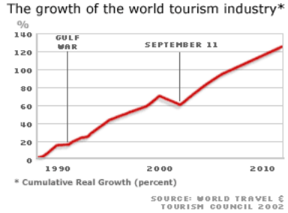

Figure 4:The growth of the world tourism industry (Tarlow 2014)

### 1.3.3 Tourism in Jordan

The tourism sector is expected to continue recovering during 2018, according to stakeholders, who urged the concerned bodies for more efforts to better promote the Kingdom and open new markets. Jordan Tourism Board (JTB) Director Abed Al Razzaq Arabiyat said that 2017 witnessed a "considerable" increase in the number of tourists according to the Central Bank of Jordan's figures. Arabiyat said that revenues from tourism during November 2017 increased by 14.3 per cent compared with the same period of 2016. He outlined a number of measures that contributed to increasing tourism indicators including coordinating with the relevant bodies in the fields of promotion. The JTB also supported the plans for stimulating the charter and low-cost flights including supporting the prices of tickets. Trip bookings to Jordan in 2018 are "promising", with fewer cancellations compared with previous years, Suleiman Abu Dalou, a tourist operator, told The Jordan Times on Wednesday. The worst year for the Jordanian tourism sector was 2011, during which the "Arab Spring" began, while the best so far was 2017, Abu Dalu said. Jordan Tourist Guides Association President Hasan Ababneh said that during the regional crisis, tourists gradually became aware of Jordan's security despite the turmoil in the region, which enhanced their confidence to come to Jordan, leading to a considerable increase in their numbers. However, the relevant institutions should exert more efforts to attract more visitors, especially from far eastern countries, said the president. (Bani Mustafa - 2018)

In 2011, Jordan has 1,300 tourist guides who spoke 39 languages, now the number has declined to 1,000 as many guides left the job as a result of the low demand or age, said Ababneh. "Now tourism is recovering and the sector needs more guides, especially those who speak far eastern languages such as Chinese and Indonesian," said Ababneh, calling for training of more guides to meet the demand. Ababneh said that the JTB has made an agreement with the relevant bodies to set official guiding fees per day at JD60.  
In recent remarks to The Jordan Times, Tourism Minister Lina Annab said that tourism figures in 2017 where higher than expected, adding that that the figures will keep increasing this year. The World Trade Organization’s figures have indicated a 4 per cent drop in tourists' numbers in the region 2017, but Jordan witnessed a hike instead, the minister said. The number of overnight tourists until the end of November increased by 9.5 per cent, reaching 3.911 million visitors, compared to 3.574 million during the same period of last year, the ministry's figures showed. Meanwhile, the number of one-day visitors during the first 11 months of this year increased by 6.4 per cent in comparison to the same period in 2016. Khader Rabbaa, a tourist restaurant owner, agreed and said that in 2017 the number of his clients increased by 25 per cent. He said that the 2018's booking are promising and include a come-back of traditional clients from Europe and the Americas. Sadam Kinj, a tourist guide, said that he has struggled for five years but in 2017 he did an adequate number of trips. Kinj said that the worst year was 2015, when he did one local tour in Jerash, 45km north of Amman, each week, while in 2017; he almost did one tour every day. (Bani Mustafa - 2018)

### 1.3.4 Technology’s role in tourism

To investigate the role of technology in the modern tourism industry or system, a model is needed which has a result in a more holistic view of the role of technology than what is provided by an industry-focused, issue-oriented or specific technology-centered approach. While it is informative to deal with technology and a particular industry element (ex. tour operator, travel agent, hotelier), a specific issue (ex. appropriate technology, environmental issues), or a specific technology (ex. the Chunnel or CRS development), a more holistic view is useful when considering the role of technology in the tourism industry. (Stipanuk 1993)

One framework for the role of technology in tourism is shown in Table 1. The roles given in this table are sometimes visible and participatory as far as the tourist is concerned while at other times they are primarily ‘behind the scenes. In addition, not all interactions of technology and tourism are internal, explicit or choices of the industry. (Stipanuk 1993)

|  |
| --- |
| **Technology’s role in tourism:** |
| Technology’s contribution to tourism growth |
| Technology as creator of the tourism experience |
| Technology as protector of the tourism experience |
| Technology as enhancer of the tourism experience |
| Technology as focal point of the tourism experience |
| Technology as tool of the tourism industry |
| Technology as destroyer of the tourism experience |

Table 1:Technology's role in tourism (Stipanuk 1993)

Technology has contributed to the massive economic growth of tourism in several ways. First, the overall societal economic growth achieved and due to applications of technology has provided the time and economic means for people to travel. The contribution of a strong economy has been illustrated recently in the negative by the significant drop in international travel as we endure the world-wide recession of the early 1990s. A positive example is the emergence of Japan as a major source of tourists, a fact which is largely attributable to significant economic growth. Some might argue that this is a second-order effect of technology on tourism. But it is still fairly clear that a robust economy is a requirement for tourism growth and that technology is a potentially significant contributor to economic growth. (Stipanuk 1993)

Tourism growth also involves and requires the application of technology. Locational factors of importance for tourism growth have been identified as climate, physical conditions, attractions, access, existing facilities, land tenure and use, and general development incentives. Technology plays a major role in several of these factors. It is possible that among the more important roles has been the contribution of technology to the traveler’s access to tourist destinations. (Stipanuk 1993)

The contribution of the development and growth of air travel as a means of tourist transportation in the mid- and late 20th century cannot be denied. Jet travel and more efficient interconnections among airlines coupled with relatively low-priced tickets have clearly contributed to the growth of destinations such as Hawaii, Mexico and various Pacific Rim destinations. The low-priced tickets are themselves the result of applications of technology which have significantly increased the range and efficiency of aircraft. The distances of these destinations from markets would clearly have precluded large-scale development without the technology of the modern air travel industry. (Stipanuk 1993)

An impact of technological change in transportation on tourist flows is further illustrated by recent articles on such diverse topics as the Chunnel, advanced cruise ship designs,” and high-speed trains.” In each of these instances, there are several possible ways in which the technological change has had or may have an impact on the tourism system, some in a positive sense and others in a negative. For example, the Chunnel development will cause a reconfiguration of tourism routes between Britain and the Continent resulting in decline for some business sectors, such as the existing ferry operations. High-speed trains may help to alleviate the overcrowding of airports and provide a rapid means of travel for those who have a fear of flying or just yearn for a new travel experience. Besides the issue of technologies’ contribution to economic growth (an immense and complex subject), tourism researchers could aid in contributing a better understanding of the positive and negative ways in which technological change (or lack of change) contributes to tourism growth. Changes in transportation appear to be among the richer areas for research but creative researchers should be able to develop further topics.

The tourism experience is potentially fragile and vulnerable to events which might fracture this experience. Tourists wish to have safe and secure experiences, even the risk-taking so-called “adventure tourists”. Technology is employed to create a protected environment in which tourists can have their experience. The protection afforded may be from natural elements (storms and local diseases) or it may involve protection from man-created dangers. In addition, technology is employed to protect the actual tourism destination/attraction itself from possible damage or degradation due to the tourist’s presence. One area in which technology is very active in this regard involves weapons and bomb detection on aircraft. X-rays, pulsed fast neutron analysis, thermal neutron analysis and gamma ray scanning are all either in use or under study as means of improving aircraft security.” While low-tech approaches (such as full searches of baggage) are also employed, the industry is clearly looking to advanced technologies to address these threats and to protect the tourist. (Stipanuk 1993)

### 1.3.5 Diffusion of Internet Technology in the Tourism Sector:

Many travel offices have built up an Internet nearness by posting a site with point by point travel data. Full travel booking locales are frequently complex and need the help of outside movement innovation arrangements suppliers, for example, Travelocity. An ever-increasing number of visitors utilize the Internet sites to book and or get valuable data. These organizations utilize travel benefit dispersion organizations who work worldwide appropriation frameworks (GDS), such as Saber Holdings, Amadeus, Galileo, and World Span, to give up-to the minute, point by point data on a huge number of flights, lodging, and auto rental opening. Some online travel locales enable guests to look at lodging and flight rates with different organizations for nothing. They regularly enable guests to sort the movement bundles by enhancements, cost, and additionally closeness to a city or milestone. As data and correspondence advances progressively enter our lives, society and the economy are adjusting to the flood of advancement that is related with this change. The improvement and utilization of organized innovations for example, the Internet will leave no industry unaffected, yet maybe impacts significantly more on the travel industry than on some other. The travel industry and innovation, being two of the biggest, most quickly developing and generally unique enterprises, have turned out to be inseparably connected, and together they are changing the manner in which society works (Sheldon, 1997).

Buhalis claims that understanding the capability of the Internet gives the travel industry firms of all sizes the chance to receive new promoting models and distribute an expansive scope of advertising content. Notwithstanding the data extraordinary nature of the travel industry item, little firms are not really capable of showcasing themselves on the web. In the neighborliness business, promoting and publicizing items, also as social affair showcase insight, has dominatingly been the area of bigger organizations and chains. One potential answer for this issue could be that little cordiality firms receive alliance and agreeable practices. Customarily, such participation has been limited to the generation of joint showcasing pamphlets and shared stands at public expos. The approach of the Internet offers extended open doors for helpful showcasing and, to date, the best enthusiasm for utilizing ICT arranges in the travel industry segment has been to create joint web based showcasing activities. Be that as it may, eminent investigation into the travel industry particular helpful utilization of the Internet as an advertising apparatus stays in its early stages. Information on customers' inquiry courses and basic leadership forms as to discovering goals online is similarly rare. (Bhat, S. A., & Shah, M. A. 2014).

### 1.3.6 The Role of Mobile Technology in Tourism

The role of information and communication technology (ICT) became important when the Internet was adopted as a distribution channel. At the time, the research on ICT revolved around PC-based Internet access and devices that used this technology, which were introduced within the concept of e-tourism (Huang, C.D.; Goo, J.; Nam, K.; Yoo.2017- Xiang, Z.; Wang, D.; O’Leary, J.T.; Fesenmaier. 2015).

The examinations were like the exploration on web-based business, in that customers received online apparatuses to take part in web-based business in the travel industry, which extended the travel industry channel, therefore, it improves the competency of the travel industry firms. Along these lines, a movement client's use design began to change and firms' reaction designs, including innovation arrangement, likewise changed. Subsequently, a survey of e-the travel industry fixated on PC-based Internet is fundamental in recognizing the connection between versatile innovation and the travel industry, since it considers changes in customer use examples and firms' mechanical reaction designs. Utilizing research on buyers' utilization of the Internet for movement arranging from the fulfillment viewpoints, Xiang et al. (2015) recognized that most explorers completely adjusted to such arranging through the Internet. They brought up that long-range informal communication destinations and video sharing are winding up more famous for excursion arranging, that the PC is being utilized less much of the time, and that tablet PCs and GPS are being utilized all the more as often as possible. Different classification strategies exist for mobile technology innovation as an empowering influence and important factor of keen the travel industry. Portable innovation can be delegated foundation that gathers and conveys information, for example, a system, a sensor, a chip and IoT, or it tends to be delegated innovation that combines analyzes and streamlines Data. On the other hand, it may be named as a platform services, for example, applications, the cloud, and open API (Koo, C.; Park, J.; Lee, J.N. 2017).

Also, portable innovation is a wide idea, it tends to be ordered into four categories. The primary class is innovation identified with information accumulation, analysis, and communication. This classification incorporates seek advances, sensors that gather information that emerge from common associations among vacationers and the earth, and short-go remote correspondence advances, for example, RFID and NFC (Basili, A.; Liguori, W.; Palumbo. 2014- Gretzel, U.; Koo, C.; Sigala, M.; Xiang, Z. 2015– Han, H.; Park, A.; Chung, N.; Lee, K.J. 2016).

At the point when clients create data utilizing geotags containing area information, technology to recover the information from the geotag and channel them is important. also, technology that recovers client profiles and incorporates other data is too important (Krinkin, K.; Yudenok, K. 2013- Teslya, N.; Ponomarev. 2017).

Technology identified with information incorporate new strategies for information gathering, information investigation, information trade, information sharing, and correspondence (Gretzel, U.; Koo, C.; Sigala, M.; Xiang, Z. 2015). Creating information logical calculations for the travel industry is likewise fundamental, although not canvassed altogether in the travel industry look into (Albusaidi, H.S.; Udupi, P.K.; Dattana, V. 2016). As of late, endeavors have been made to examine a goal's picture from the point of view of data quality, which demonstrates that information representation is likewise turning into a concentration in this field (Kim, S.-E.; Lee, K.Y.; Shin, S.I.; Yang, S.-B. 2017). In the travel industry, innovation must combine information and data, and support ubiquitous network and ongoing synchronization to make new experiences for clients. (Neuhofer, B.; Buhalis, D.; Ladkin, A. 2015).

**1.3.6 Convolution Neural Network Model and Improvement**

**Convolutional neural network (CNN)** is a high-efficiency identification method which has been developed in recent years and has attracted wide attention from society. At present, convolution neural network has become one of the hotspots in many scientific fields. Convolution neural network has a unique superiority in speech recognition and image processing with its special structure shared by local weights, especially the image of multi-dimensional input vector can be directly input to the network for parallel learning, avoiding the complexity of feature extraction and classification process of data reconstruction, thus has been more widely used. Convolution neural networks are mainly used to identify two-dimensional images of displacement, scaling and other forms of twist invariance. (Guifang Lin et al. / Procedia Computer Science 131 (2018) 977–984)

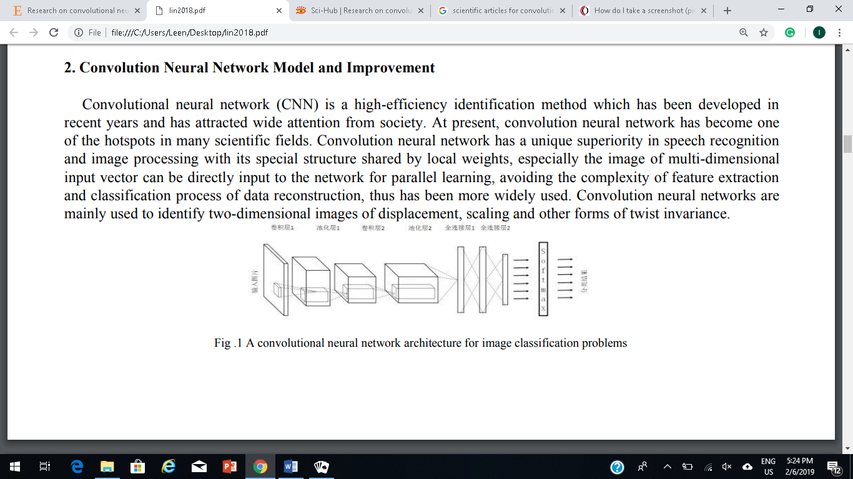

Figure 1: A convolutional neural network architecture for image classification problems

Figure 1 shows a concrete convolution neural network architecture. According to the figure, a convolutional neural network is mainly composed of five layers: input layer, convolution layer, pool layer, all-layer layer and Softmax layer. The input layer is the input of the whole neural network. In the image processing of the CNN model, it represents a pixel matrix of a picture. The convolution layer is the most important part of a convolutional neural network. The input of each node in the convolution layer is only a small part of the upper layer of the neural network. The convolution layer analyses every smaller part of the neural network in depth, and as far as possible to get a higher degree of feature abstraction. The pooling layer does not change the depth of the three-dimensional matrix in the neural network, but it will reduce the size of the matrix, that is, reduce the number of nodes in the next layer, so as to reduce the parameters of the whole neural network and decrease the training time. After multiple rounds of convolutions and pooled layers, the information in the image has been abstracted into a higher information content, and the full connection layer is used to complete the classification task. The fully connected layer performs the combination matching and classification by modifying the nonlinear activation function, mainly used for classification problems, through the Softmax layer, you can get the sample belongs to different types of probability distribution. (Guifang Lin et al. / Procedia Computer Science 131 (2018) 977–984)

Convolution neural network model design is shown in Figure 2, which is divided into convolution layer Conv, pool layer pool, local response normalization (LRN) layer nom, full connection layer Local, the output layer Softmax. The first two layers are convolutions, and each convolution layer is followed by a maximum pooling layer and a localized normalized layer. The third and fourth layers are the full connection layer and the last layer is the output1 layer.

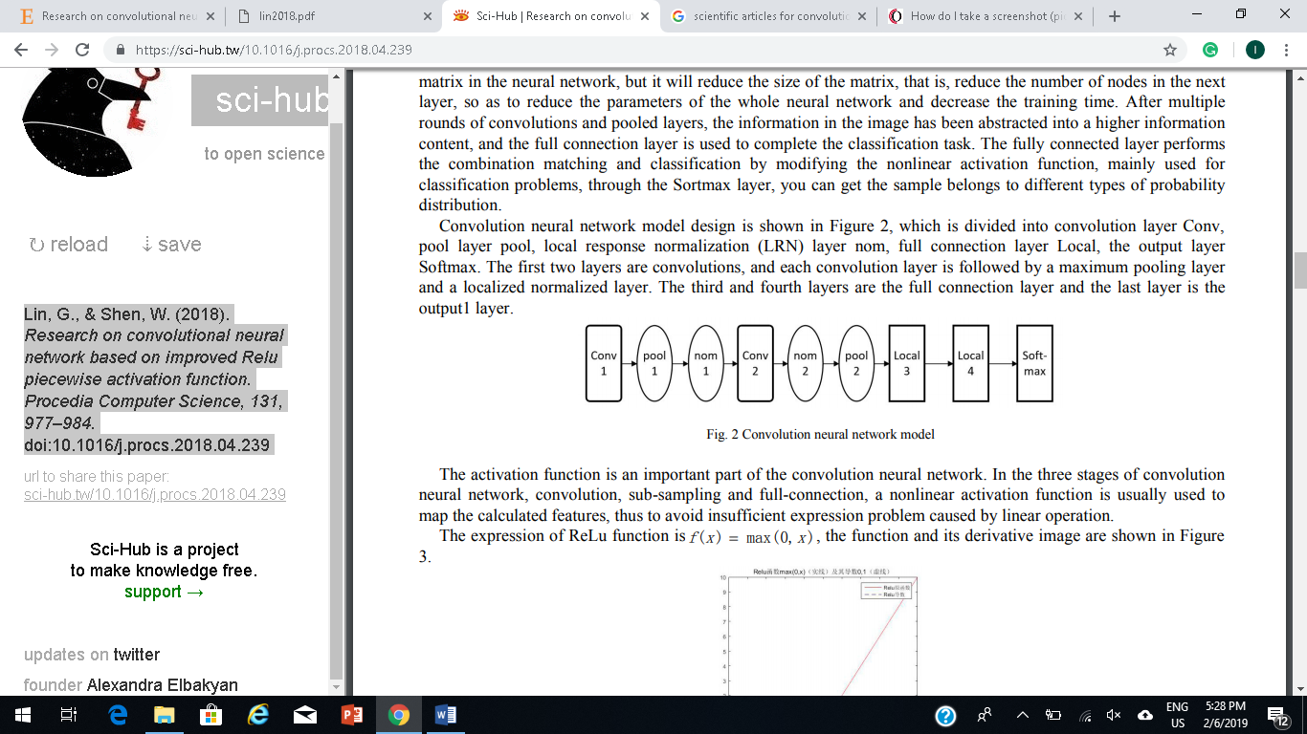

Figure 2: Convolution neural network model

The activation function is an important part of the convolution neural network. In the three stages of convolution neural network, convolution, sub-sampling and full-connection, a nonlinear activation function is usually used to map the calculated features, thus to avoid insufficient expression problem caused by linear operation. (Guifang Lin et al. / Procedia Computer Science 131 (2018) 977–984)

The expression of ReLu function

is f(x ) = max(0,x ), the function and its derivative image are shown in Figure 3

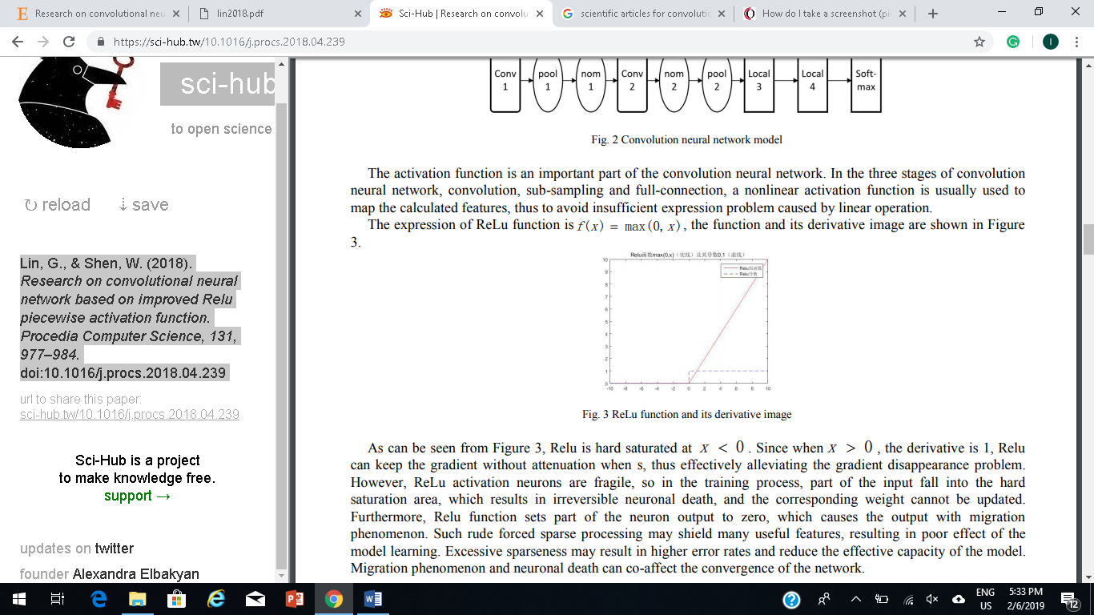

Figure 3: ReLu function and its derivative image

As can be seen from Figure 3, Relu is hard saturated at x < 0 . Since when x > 0 , the derivative is 1, Relu can keep the gradient without attenuation when s, thus effectively alleviating the gradient disappearance problem. However, ReLu activation neurons are fragile, so in the training process, part of the input fall into the hard saturation area, which results in irreversible neuronal death, and the corresponding weight cannot be updated. Furthermore, Relu function sets part of the neuron output to zero, which causes the output with migration phenomenon. Such rude forced sparse processing may shield many useful features, resulting in poor effect of the model learning. Excessive sparseness may result in higher error rates and reduce the effective capacity of the model. Migration phenomenon and neuronal death can co-affect the convergence of the network. The expression of Softsign function is f(x ) = x/ (x + 1),the function and its derivative image are shown in Figure 4. (Guifang Lin et al. / Procedia Computer Science 131 (2018) 977–984)

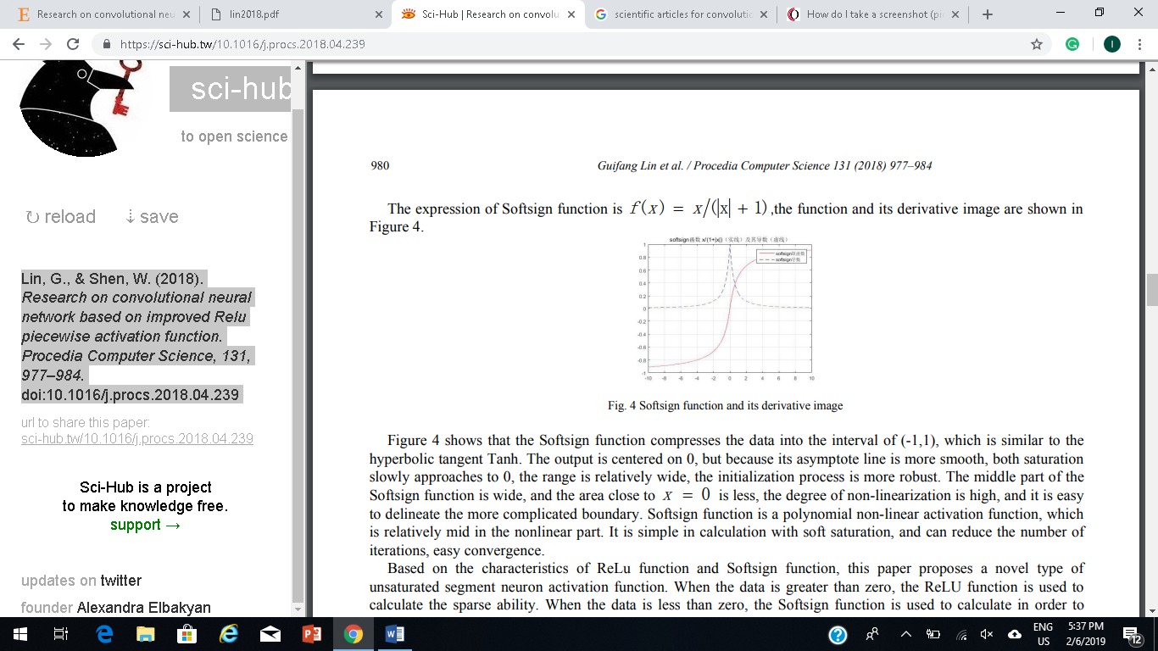

Figure 4: Softsign function and its derivative image

Figure 4 shows that the Softsign function compresses the data into the interval of (-1,1), which is similar to the hyperbolic tangent Tanh. The output is centered on 0, but because its asymptote line is more smooth, both saturation slowly approaches to 0, the range is relatively wide, the initialization process is more robust. The middle part of the Softsign function is wide, and the area close to x = 0 is less, the degree of non-linearization is high, and it is easy to delineate the more complicated boundary. Softsign function is a polynomial non-linear activation function, which is relatively mid in the nonlinear part. It is simple in calculation with soft saturation, and can reduce the number of iterations, easy convergence. Based on the characteristics of ReLu function and Softsign function, this paper proposes a novel type of unsaturated segment neuron activation function. When the data is greater than zero, the ReLU function is used to calculate the sparse ability. When the data is less than zero, the Softsign function is used to calculate in order to retain its negative axis information to correct the data distribution and ensure that it has a better fault tolerance. In this paper, the improved activation function is denoted as SignReLu function, the expression is set as follows:

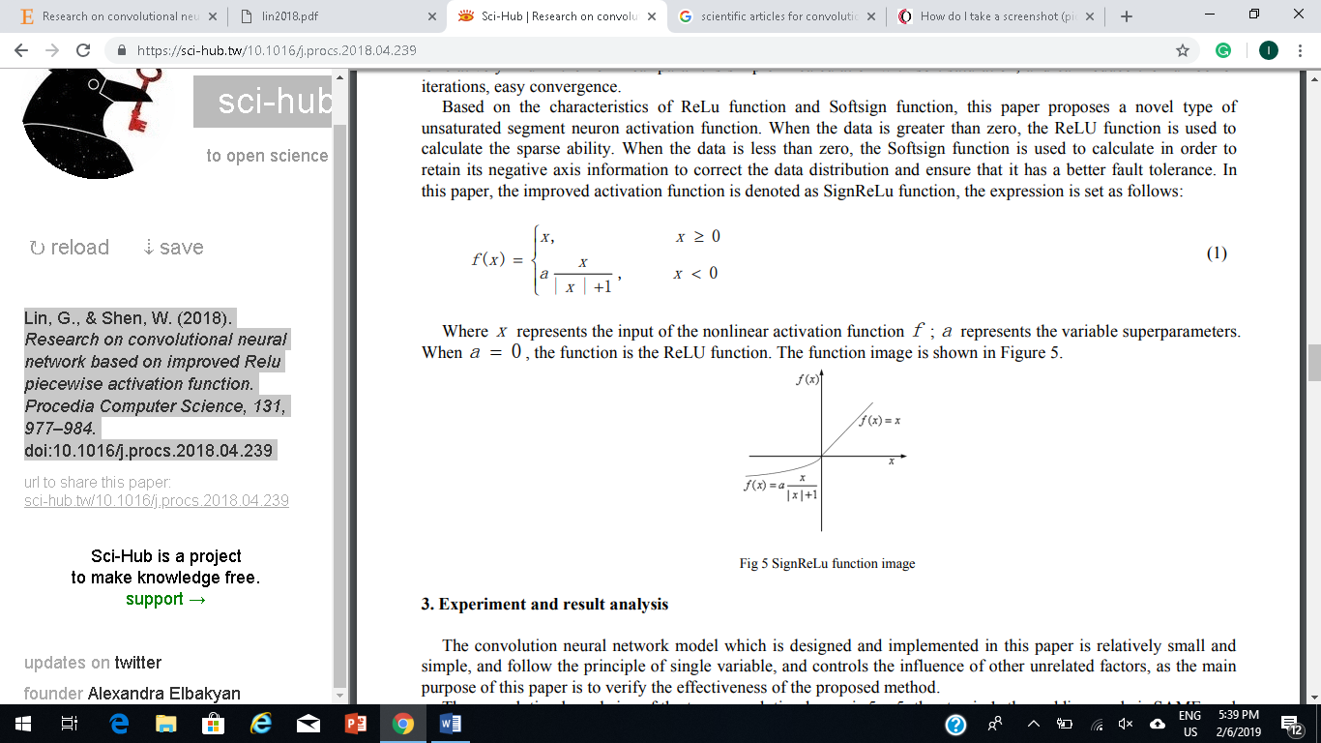

Where x represents the input of the nonlinear activation function f; a represents the variable superparameters. When a = 0 , the function is the ReLU function. The function image is shown in Figure 5.



Figure 5: SignReLu function image

(Guifang Lin et al. / Procedia Computer Science 131 (2018) 977–984)

### 1.3.7 Conclusion:

In conclusion tourism in general is one of the main incomes to any country, especially in Jordan so, to improve tourism it has great impacts on the Jordanian Economy. Moreover, people come from different countries in the world to witness Jordan’s archeological places. As a result, any mistake in the information about these places will cause serious gap in knowledge for people to these places which will lead to be seen as less valuable than what they really are. We all use technology nowadays so the best way to help save the historical places’ values is to make them merge into technology.

## 1.4 Project objectives:

***Objective 1:*** Increase the efficiency of tourism in Jordan.

***Objective 2:*** Decrease the pressure of work on tour guides.

***Objective 3:*** Offer tourists information about historical places and give them full details of these places.

***Objective 4:*** improve Jordanian’s knowledge in historical places in Jordan and their full events.

***Objective 5:*** Shorten the time needed to get to the places that users want to go by showing them the shortest path to take to get to the place’s destination.

***Objective 6:*** Reduce dangerous risks that is caused by the weather and the place’s geographical nature.

## 1.5 Stakeholders list:

|  |  |  |
| --- | --- | --- |
| Stakeholders | Interest | Importance |
| Dr. Ahmad Shubeita | Supervisor. | High |
| Walaa Abu Mailish  Raghad Rabah  Leen Attari Aya Alatoom | Developers of the App. | High |
| Dr. Abdelkareem Albanna Dr. Yaser Saleh | Technical Help. | High |
| Users | Will be using this App. | High |
| Ministry of Tourism | Responsible for putting rules, regulations and constraints. | Low |
| Tourism Company | Responsible for giving information about the historical places. | High |

Table 2: Stakeholders

## 1.6 Scope excluded and Project constraints:

### 1.6.1 Scope excluded:

The project will not implement the comment on places functionality with checking the comments if appropriate to post. We will also not be able to implement the text-to-voice command since the lack of time we have. The application will not be implemented as an IOS application due to the inability to learn the IOS programming language. This project will only be set to work as an android application and will not be implemented as a website. Also, it won’t include places other than historical sites. It will not include any sites that are outside the Jordanian borders.

### 1.6.2 Project constraints:

Due to the time constraint of the project (3 months only), and the fact that there is a lack in knowledge in Android and python programming languages. At this time, we will be working only on Jordanian archeological sites. Also, we will implement the application only on android platform, which means that this application will be available only on android smartphones. Only 20 sites will be included in the system, 10 of them can be searched for via image.

## 1.7 Proposed Scope and Process Model:

### 1.7.1 Proposed scope:

We will design and develop an android application to perform the following activities: the system will allow users to create an account on the application to keep track on any updates to the places they have visited. It will also allow users to login into the users accounts and the admins to access their admin accounts. Also, it will offer to users information about historical place that they are at by searching for the place and it will display to the users’ ratings to these places in addition to the directions to these places. It will also show details of the place including weather, fees (if any) and age restrictions whether this place is text or was picture searched. It will allow admins to add, update or delete places on the system.

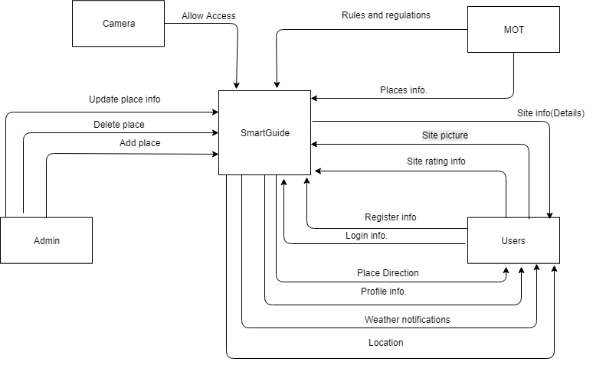

Figure 5: Proposed Scope

### 1.7.2 Process model

We will be using Unified process model to develop our application, which is an iterative and incremental model to adapt the project needs. Development is divided into short fixed-length mini projects called iterations. It is a risk-driven development because each iteration has requirement analysis, design, implementation and testing. And the output of each iteration is tested, integrated executed system that grows with each iteration. We will use this process model in order to keep our activities adaptive and to manage the complexity of the project by dividing the problem into smaller ones. Each iteration is 10 days and each member will work on one functional requirement during the iteration.

# Chapter two

# Planning and requirements

## 2. Planning and Requirements

## 2.1 Planning

### 2.1.1 Scope Initiation (WBS)

Because we choose the unified process model to develop the project with 11 days long iteration, the following tables show the work breakdown structure of our project.

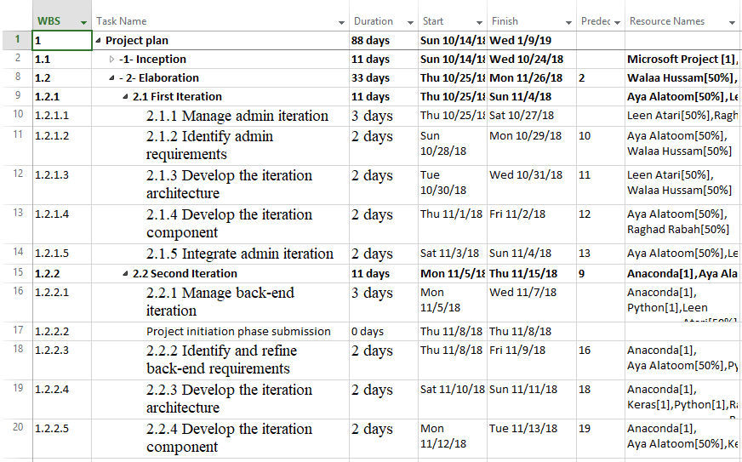

Table 3: WBS

**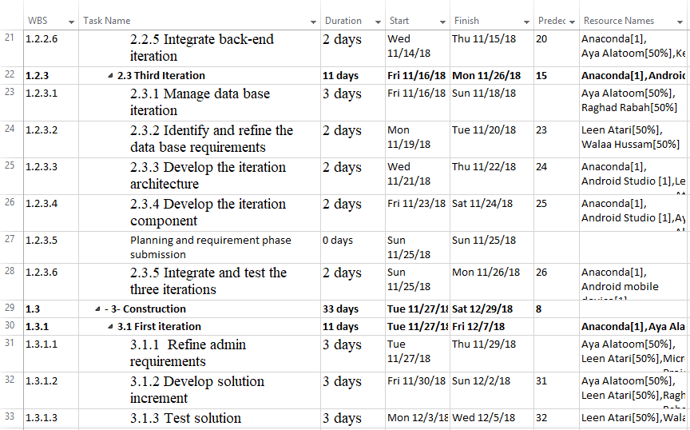**

Table 4:WBS

**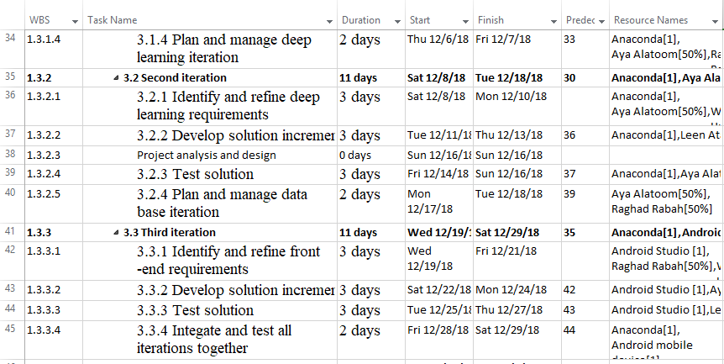**

Table 5: WBS

**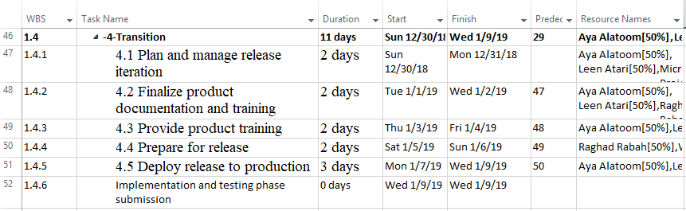**

Table 6: WBS

### 2.1.2 Gantt chart

Based on the previous work breakdown structure, the following figures show the Gantt chart of our project.

**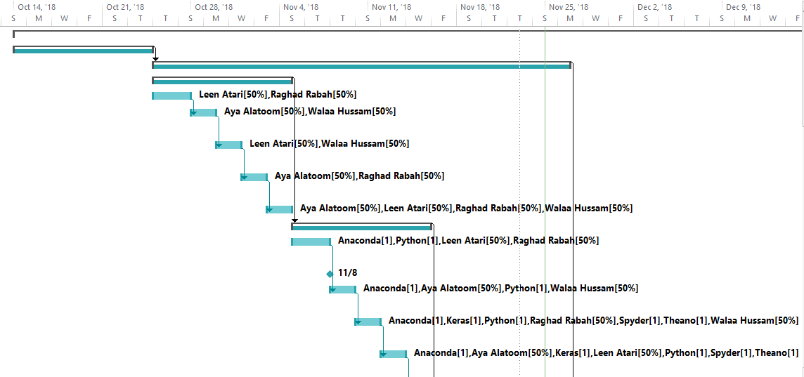**

Figure 6:Gantt Chart

**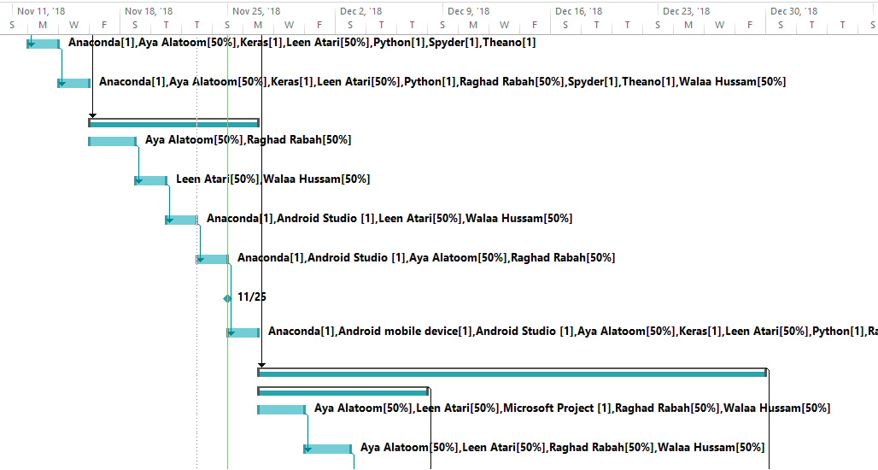**

Figure 7:Gantt Chart

**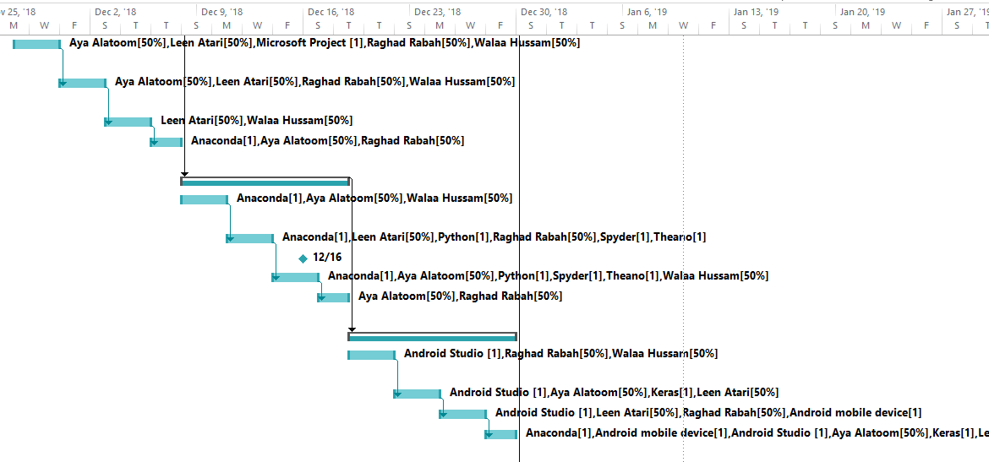**

Figure 8:Gantt Chart

**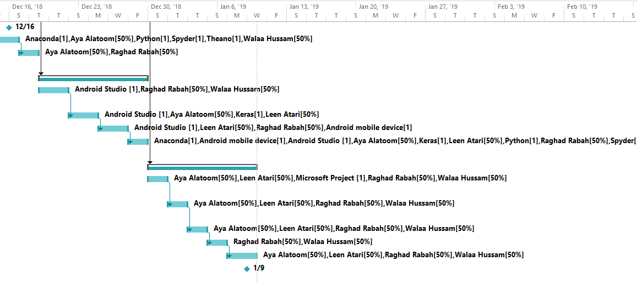**

Figure 9:Gantt Chart

### 2.1.3 Resource Planning Scheduling and Resources Distribution

Human, software and hardware resources are allocated for each task in the WBS. The figure below shows the resources distribution and planning scheduling.

**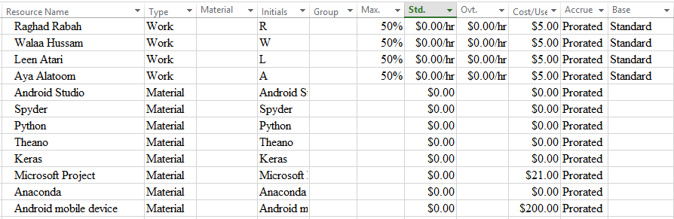**

Figure 10:Resource Sheet

**More details of the Resource planning scheduling and resources distribution are in the attached file “Project1.Microsoft project”.**

### 2.1.4 System Development Requirements:

The table below shows the resources needed to develop our application. The human resources represent us as developers of the application. We need mobiles and android studio as a technology to develop the App.

|  |  |
| --- | --- |
| **Resource Group** | **Resources name** |
| **Human resources** | * Raghad Rabah * Walaa Hussam * Leen Atari * Aya Alatoom |
| **Software** | * Android Studio * Anaconda (Spyder) * Keras * TensorFlow * Microsoft Project |
| **Hardware** | * Android device |

Table 7: Resources

### 2.1.5 Cost estimating and budgeting

The following table and figures show the cost of the resources in our project.

|  |  |
| --- | --- |
| **Resource Name** | **Total cost** |
| **Human resources** | 440 (Month) \* 4 (Human resources) = 1760 $ / Month |
| **Software** | Android studio: Free (Developer.android)  Anaconda: Free (Python)  Spyder: Free (Anaconda)  Theano: Free (Conda)  Keras: Free (Conda)  TensorFlow: Free (Conda)  Microsoft project: 21$ (Project online essentials) |
| **Hardware** | Android device: 200 $ |

Table 8: Cost of resources

**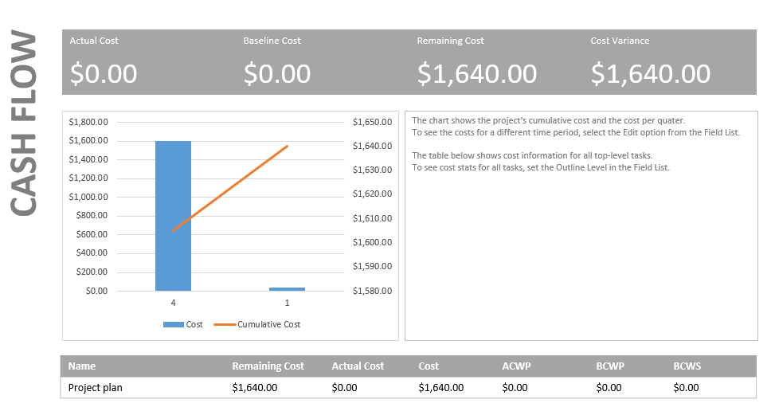**

Figure 11:Cash Flow

**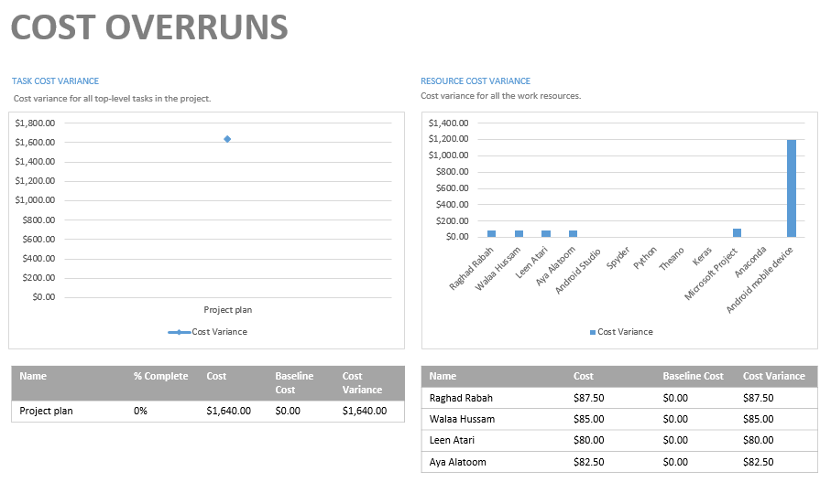**

Figure 12:Cost overruns

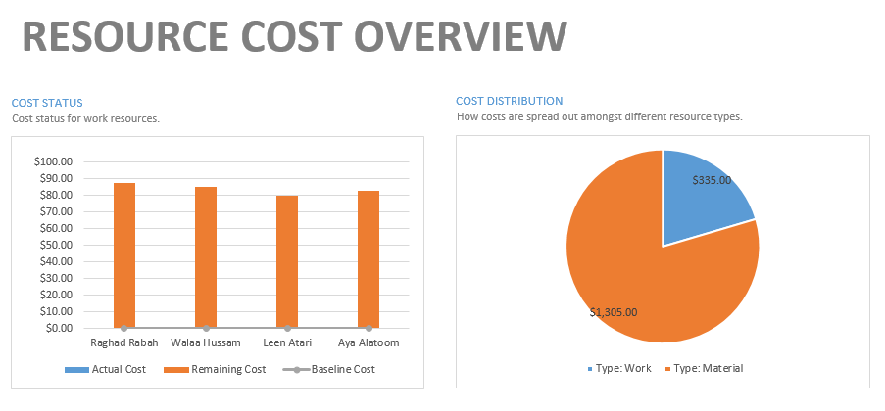

Figure 13:Resource cost overview

### 2.1.6 Risk List:

* Developing an android mobile application.
* Publishing the Application on the App Store.
* Lack of knowledge in both android and python.
* Accomplishing the application before the deadline.

## 2.2 Requirements

### 2.2.1 Elicitation Techniques

### 2.2.1.1 Brainstorming:

We have done a brainstorming session with our supervisor dr. Ahmad Shubeita and our instructor dr. Yaser Saleh, which consisted of 4 meeting.

In the first meeting, we have discussed the idea of the project in addition to what is the goals of this project with a very brief summary of what the system is expected to do.

In the second meeting, the project’s name, scope of the system and process model were set, the domain of the project was defined, and the problem definition was written. The objectives were set, and the stakeholders were defined, including the current and existing systems that were similar to our system. With the literature review of our project.

In the third meeting, the project technical tools were discussed, and the technical ways of our system were defined. In addition, to what techniques our system will be using.

In the fourth meeting, functional and non-functional requirements were defined, use cases were written. Risks were listed, the resources with their costs were estimated. The WBS and the Gantt Charts were drawn. Questionnaire questions were set.

### 2.2.1.2 Questionnaire:

We prepared a questionnaire for local, regional and international tourists, which aims to study the success rate of our project. The questionnaire is online at:

<https://docs.google.com/forms/d/e/1FAIpQLSd5MEN9Dq3VEJvanx-I3msldm8kzgxNAbIEpPSmjcCgklp53A/viewform?fbclid=IwAR00-6_3MIBMGCqujLMbExYlD8b5GX6v7G50wen1eaABD-5kMLR7jWTQicI>

**Details of the questionnaire is in Appendix A.**

### 2.2.2 Use Case specification

#### **2.2.2.1 Functional Requirements:**

1. The system shall allow the user to create an account.

2. The system shall provide login for the users.

3. The system shall provide picture searching property.

4. The system shall be able to apply Convolutional layer.

5. The system shall be able to apply pooling layer.

6. The system shall be able to apply Flattening layer

7. The system shall be able to predict images of places.

8. The system shall provide view places’ information.

9. The system shall allow the user to rate the places.

10. The system shall provide directions by google map.

11. The system shall allow the admin to add new places or information.

12. The system shall allow the user to update places or information.

13. The system shall allow the user to delete places or information.

#### **2.2.2.2 Non-Functional Requirements**

* The system shall be easy to use and learn by different users (Usability).
* The system shall be able to tolerate when a user enters a wrong input (robustness).
* The system shall provide accuracy 70% to identify place’s images. (Accuracy)
* The system shall be accessible and usable by only authorized users using authorized ways (Security).

#### **2.2.2.3 Use Cases**

**Use case specification**

**1. Create an account**

**Use case name:** user sign-up.

**Pre-condition:** the user doesn’t have an account.

**Interested stakeholders:** Tourists, Tourism companies.

**Brief Description:** The user creates an account by entering the user’s information in the right fields.

**Flow of Events:**

1. The user chooses the sign-up property.

2. The system displays a form to sign-up to the system.

3. The user fills all the form with the required information.

4. The user agrees on the rules and regulations of the system.

5. The system checks the information that was filled by the user.

6. The account is added to the database.

**Alternate flows:** None

**Post condition:** account is created.

**Exception:** Invalid user account information: username already exists, or not all fields were filled, or the fields weren’t filled with the right format. The user can re-enter the fields that were written wrongly.

**2. User login**

**Use case name:** Login to the system.

**Pre-condition:** user has an account.

**Interested stakeholders:** Tourists, tourism companies, Admin.

**Brief Description:** Users enter username and password to access their profile page.

**Flow of Events:**

1. The user chooses the login property.

2. The system requests the user to enter email and password.

3. The user enters the email and password.

4. The system checks if the email and password entered were right.

5. The account is logged in.

**Alternate flows:**

**Post condition:** User access their profile page.

**Exception:** Invalid email or password: An invalid email or password is entered. The user can re-enter the email and password.

**3. Picture searching**

**Use case name:** Picturesearching

**Pre-condition:** User is logged into the account.

**Interested stakeholders:** Tourists, Tourism companies, Admin.

**Brief Description:** User takes a picture of the place to obtain information about it.

**Flow of Events:**

1. The user chooses to take a picture property.

2. The user takes a picture of the place.

3. The system checks the picture taken.

4. The system displays information about the place.

**Alternate flows:** None.

**Post condition:** Users obtain information about the historical place.

**Exception:** can’t recognize the place: the picture that was taken is blurry or isn’t included in the app. The user can retake the picture of the place.

**4. Add new places**

**Use case name:** Add new place.

**Pre-condition:** Admin is logged into the admin account.

**Interested stakeholders:** Admin.

**Brief Description:** The admin adds a new place to the system by entering it’s information.

**Flow of Events:**

1. The admin chooses the add place property.

2. The system displays the form to add a place.

3. The admin fills the place’s information form.

4. The system checks if the place already exists.

5. The new place is added to the system’s database.

**Alternate flows:** None.

**Post condition:** The place is added for all users.

**Exception:** Place already exists. Admin can choose to update the place that already exists.

**5. Update places**

**Use case name:** Update places.

**Pre-condition:** The admin is signed in the admin account.

**Interested stakeholders:** Admin.

**Brief Description:** The admin updates the place’s information.

**Flow of Events:**

1. The admin chooses the place wanted to update

2. The system displays the place with the info.

3. The Admin updates the place’s information.

4. The system adds the changes that were made to the database.

**Alternate flows:** None.

**Post condition:** the changes are displayed for the user.

**Exception:** The place’s information can’t be empty: The admin has set the place name and description to be empty. The admin can reenter the place name and description.

**6. Delete places**

**Use case name:** Delete places.

**Pre-condition:** Admin is signed in to the admin account.

**Interested stakeholders:** Admin.

**Brief Description:** The admin deletes a place from the system.

**Flow of Events:**

1. The admin chooses the place wanted to delete.

2. The system displays the place with the info.

3. The Admin chooses to delete the place.

4. The admin confirms on the deletion process.

5. The system deletes the place from the database.

**Alternate flows:** None.

**Post condition:** the place isn’t available on the system anymore.

**Exception:** None.

**7. Provide directions**

**Use case name:** Provide directions by google maps.

**Pre-condition:** User should be log in to his account.

**Interested stakeholders:** Tourists, Tourism companies.

**Brief Description:** The system displays a map using google maps to the user with the directions to the searched place.

**Flow of Events:**

1. The user searches for the place wanted to visit.

2. The system shows the results for the searched place.

3. The user chooses the place and clicks on directions for that place.

**Alternate flows:** None

**Post condition:** the direction for the place is shown.

**Exception:** the place not available: the place that was searched isn’t included in the system or wasn’t written correctly. The user can reenter a place to give directions for.

**8. Preview place’s information**

**Use case name:** Preview places.

**Pre-condition:** the user is signed in to his account.

**Interested stakeholders:** Tourists, tourism companies, Admin.

**Brief Description:** Users search for a place then the information for that place is displayed.

**Flow of Events:**

1. The user searches for the place wanted to preview.

2. The system displays the place searched for.

3. The user chooses the place.

4. The place’s information is displayed for the user.

**Alternate flows:** None.

**Post condition:** Reviews are displayed for users.

**Exception:** the place isn’t available: the place that was searched for isn’t included in the system or wasn’t written correctly. The user can reenter the place.

**9. Rate places**

**Use case name:** Rate places.

**Pre-condition:** User sign in to his account.

**Interested stakeholders:** Tourists, Tourism companies.

**Brief Description:** Users rate the places after visiting them or by searching for them.

**Flow of Events:**

1. The user searches for the place wanted to rate.

2. The system displays the place searched for.

3. The user chooses the place.

4. the user chooses the rate option and rate the place.

5. The system updates the rate on the system.

**Alternate flows:** None.

**Post condition:** the rates are displayed for users.

**Exception:** the place isn’t available: the place that was searched for isn’t included in the system or wasn’t written correctly. The user can reenter the place.

**10. Apply Convolutional Layer**

**Use case name:** Apply Convolutional layer

**Pre-condition:** Convolution layer is initiated and Images are sent to the keras model.

**Actor:** Keras model.

**Brief Description:** The system applies the convolutional layer.

**Flow of Events:**

1. The system receives the image.

2.The Feature detector which is a matrix of 3x3 applies to the images.

3. the system multiplies the feature detector with parts of the input image matrix, taken from left to right and top to bottom, based on the size of the feature detector.

4. The feature detector produces featured maps.

5. The system repeats the steps depending on the number of convolutional layers.

6. The system removes negative numbers from the matrix by applying the ReLu activation function.

**Alternate flows:** None.

**Post condition:** Featured maps are produced.

**Exception:** None.

**11. Apply Pooling layer.**

**Use case name:** Apply pooling layer.

**Pre-condition:** Featured maps are produced from the inputted image.

**Actors:** Keras Model.

**Brief Description:** The system applies the pooling layer by applying max pooling to produce the pooled maps.

**Flow of Events:**

1. The system receives the featured maps.

2. The system applies a 2x2 matrix and applies max pooling to it.

3. The system moves the matrix on the featured map , left to right and top to bottom, and take the maximum value in the matrix.

4. The system repeats it until it reaches the bottom right corner of the feature map.

5. The system saves the most important Features in a pooled map.

**Alternate flows:** None.

**Post condition:** Pooled maps are produced.

**Exception:** none.

**11. Apply Flattening layer.**

**Use case name:** Apply flattening layer.

**Pre-condition:** Pooled maps are produced from previous layer.

**Actors:** Keras Model.

**Brief Description:** The system fits the pooled maps into the ANN by inputting them as a vector.

**Flow of Events:**

1. The system receives the pooled maps.

2. The system takes each cell of the pooled feature map, left to right and top to bottom, and add it to the vector.

3. the system repeats the previous step on every pooled map produced.

3. The system inputs the vector produced to the fully connected ANN.

**Alternate flows:** None.

**Post condition:** Input layer of the ANN is produced.

**Exception:** none.

**11. Predict image.**

**Use case name:** Predict image.

**Pre-condition:** Image is included in

**Actors:** Android application.

**Brief Description:** The android application sends the image to the keras model to predict the image.

**Flow of Events:**

1. The application sends the picture into the keras model.

2. The system checks the features of the image and maps it to a featured map.

3. The system finds the most important features of that image and maps them into a pooled map.

4. The system feeds the pooled map to the ANN as an input layer.

5. The system inputs the input layer into the hidden layers.

6. The hidden layer outputs the prediction value.

**Alternate flows:** None.

**Post condition:** The prediction of the image is outputted.

**Exception:** none.

2.2.3 Domain Object Diagram

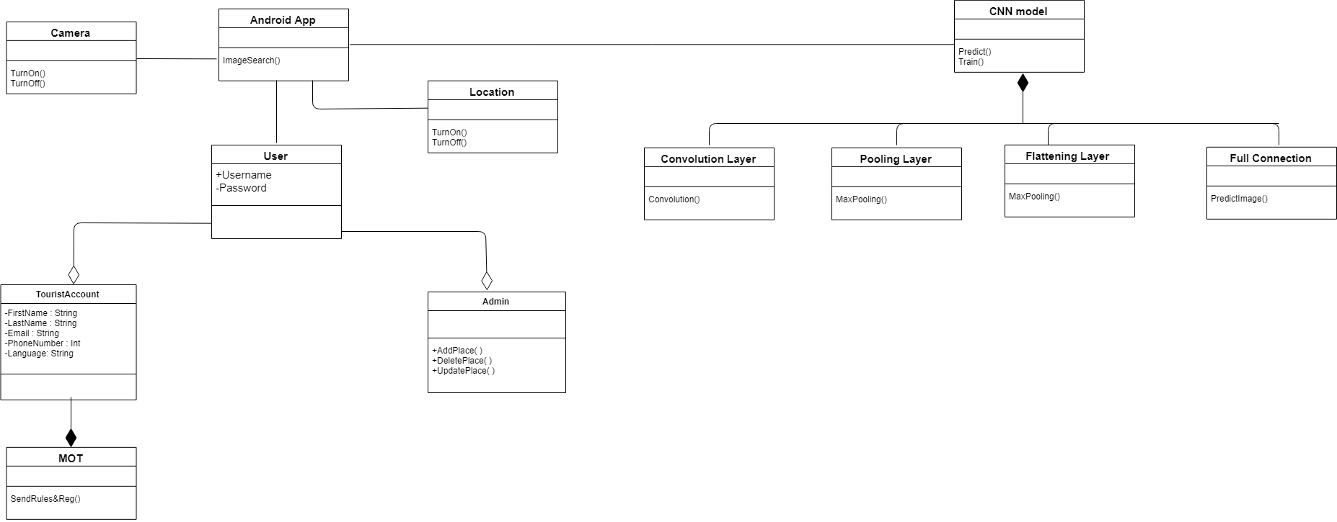

Figure 14: Domain Object Diagram

# Chapter Three

# Project analysis and Design

**3. Project Analysis and Design**

## 3.1 Use Case Diagram

The diagram shows the actors and use cases of the system extracted from the functional list in section (2.2.2.1).

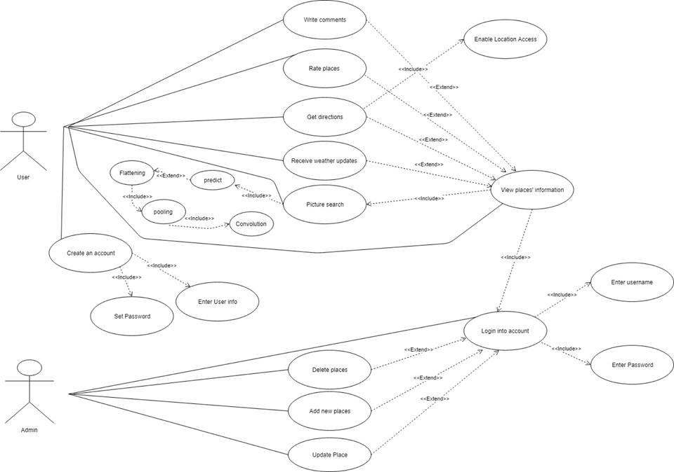

Figure 15: Use case Diagram

## 3.2 Activity Diagram

### 3.2.1 Sign up activity.

The activity shows the function of Signing up according to the use case. 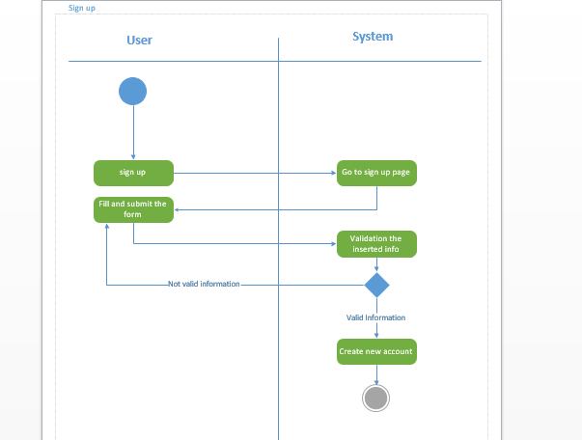

Figure 16: Sign up activity diagram

### 3.2.2 Login activity.

The activity shows the function of login to account according to the use case.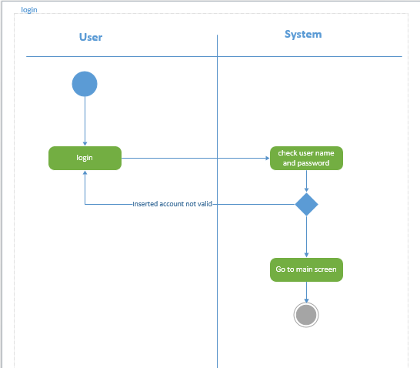

Figure 17:Login activity diagram

### 3.2.3 Picture searching activity.

The activity shows the function of picture searching according to the use case.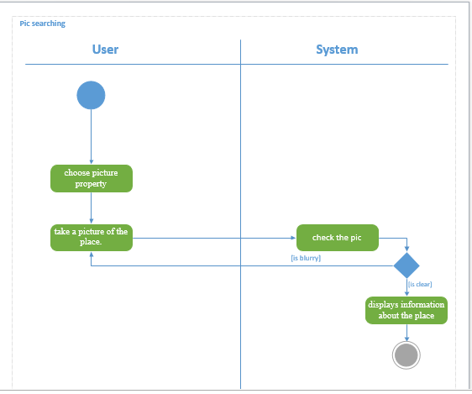

Figure 18:Picture searching activity diagram

### 3.2.4 Add new places activity.

The activity shows the function of adding a new place according to the use case.

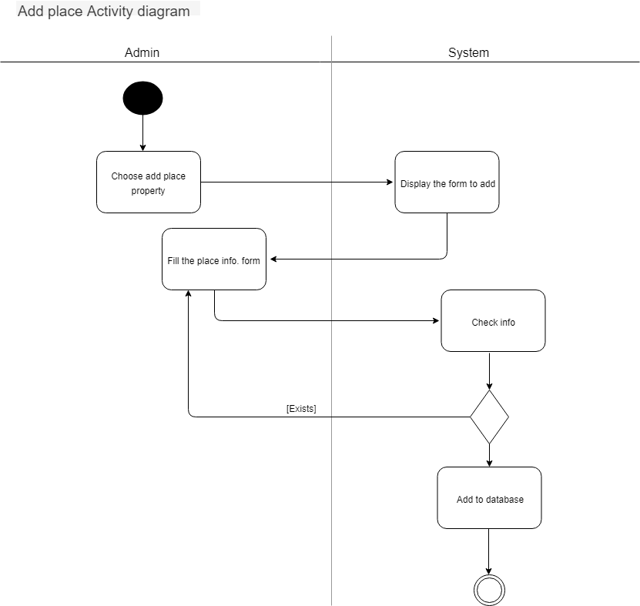

Figure 19:Add new place activity diagram

### 3.2.5 Update places activity.

The activity shows the function of updating places according to the use case.

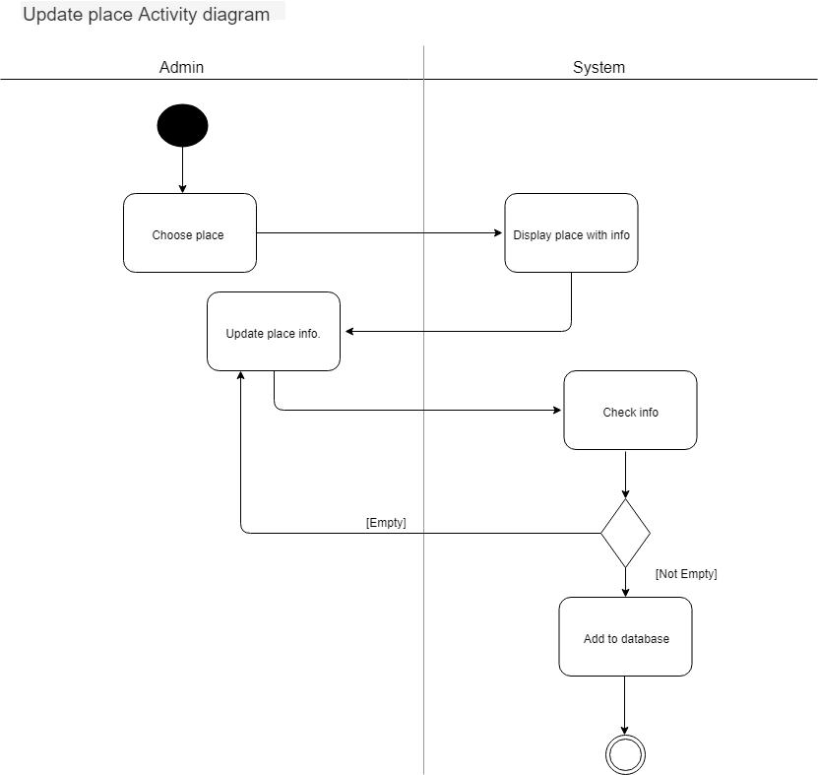

Figure 20:Update activity diagram

### 3.2.6 Delete places activity.

The activity shows the function of delete a place according to the use case.

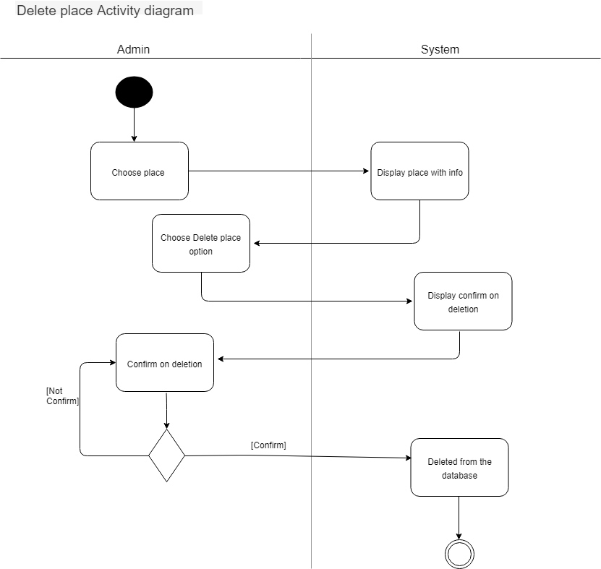

Figure 21:Delete place activity diagram

### 3.2.7 Preview places information activity.

The activity shows the function of previewing places’ information according to the use case.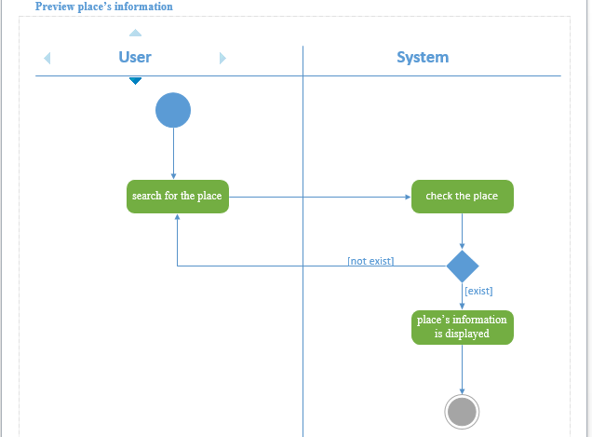

Figure 22:preview places information activity diagram

### 3.2.8 Rate place activity.

The activity shows the function of rating place according to the use case.

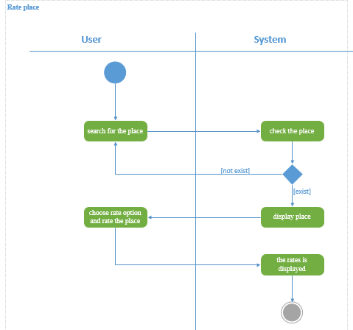

Figure 23:Rate place activity

## 3.3 Sequence Diagrams:

### 3.3.1 Add place.

This sequence shows how admin adds a place, the classes involved in this function are Android Activity Server which is the UI, the Service Server handle background processing associated with an application, the Content Provider which handle data and database management issues, and the database.

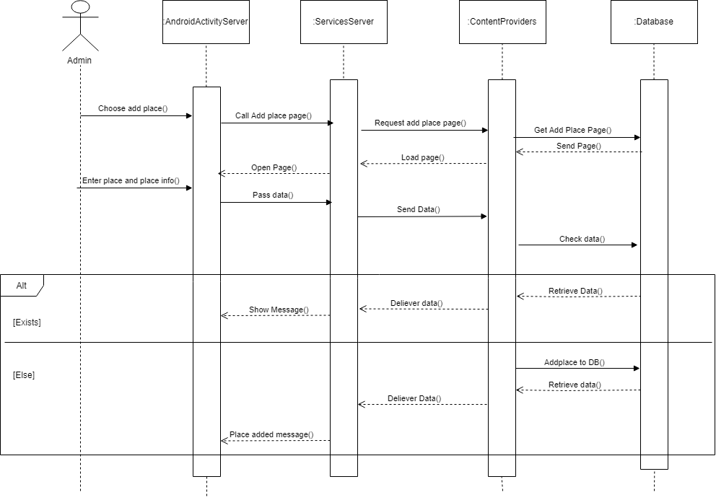

Figure 24:Add place sequence Diagram

### 3.3.2 Delete place.

This sequence shows how admin Delete a place, the classes involved in this function are Android Activity Server which is the UI, the Service Server handle background processing associated with an application, the Content Provider which handle data and database management issues, and the database.

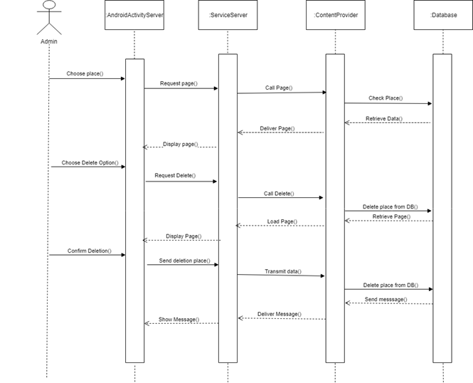

Figure 25: Delete sequence diagram

### 3.3.3 Login.

This sequence shows how admin login into account, the classes involved in this function are Android Activity Server which is the UI, the Service Server handle background processing associated with an application, the Content Provider which handle data and Database management issues, and the database.

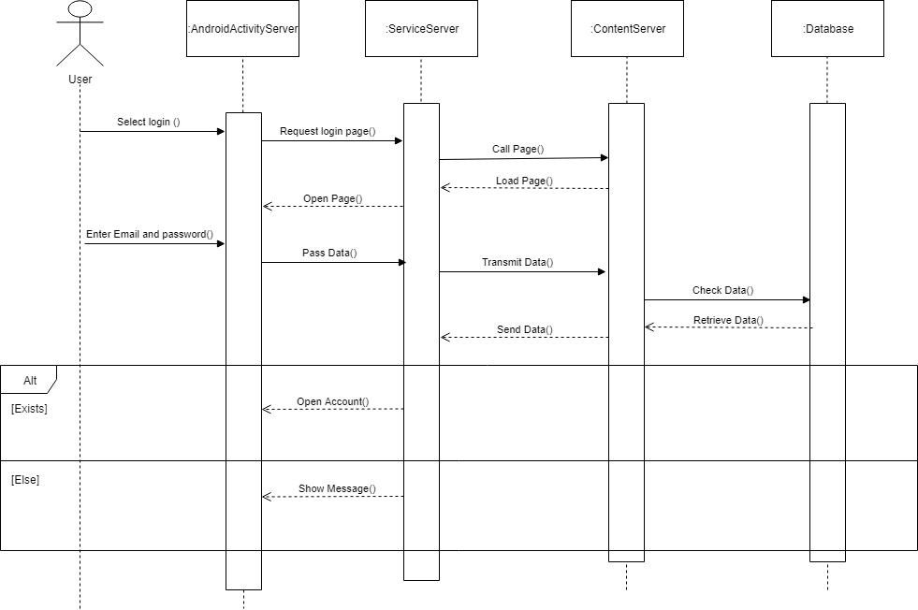

Figure 26:Login sequence Diagram

### 3.3.4 Preview info.

This sequence shows how user can preview information about place, the classes involved in this function are Android Activity Server which is the UI, the Service Server handle background processing associated with an application, the Content Provider which handle data and database management issues, and the database.

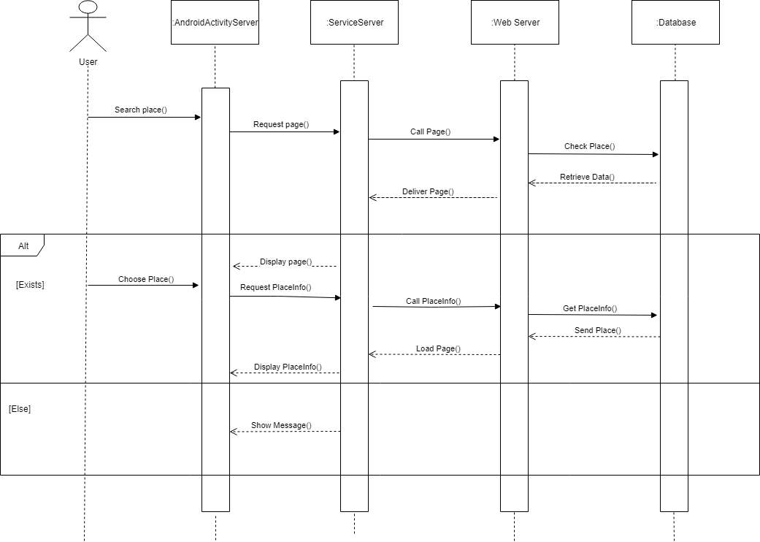

Figure 27: Preview Information about place

### 3.3.5 Rate place.

This sequence shows how user can rate a place, the classes involved in this function are Android Activity Server which is the UI, the Service Server handle background processing associated with an application, the Content Provider which handle data and database management issues, and the database.

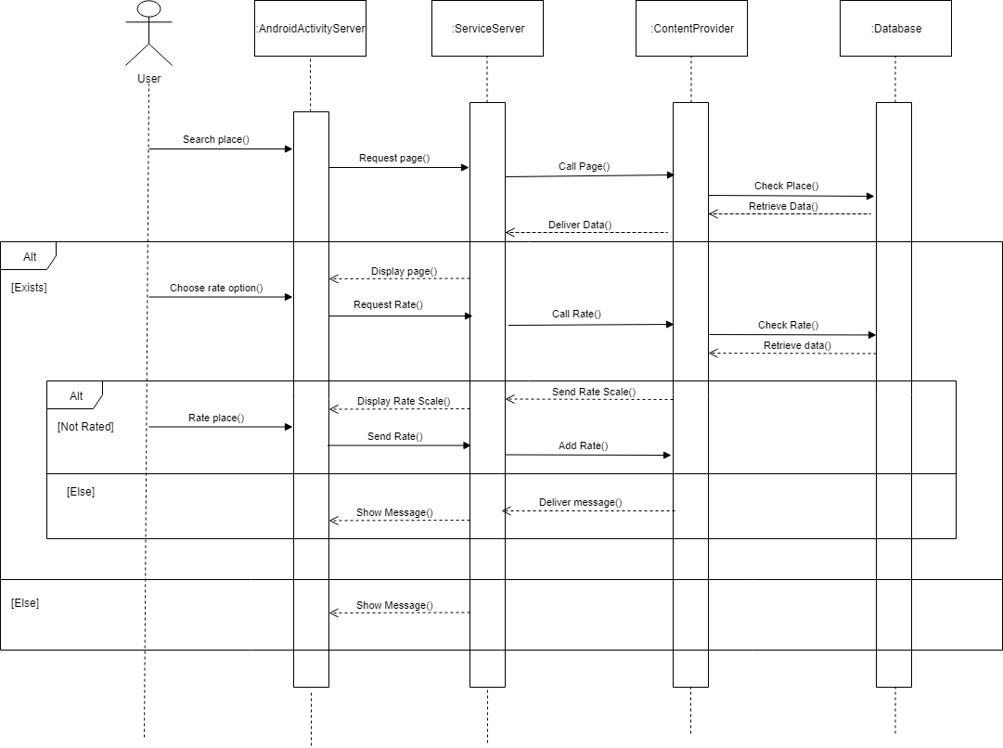

Figure 28:Rate place sequence diagram

### 3.3.5 Sign up

This sequence shows how user can sign up, the classes involved in this function are Android Activity Server which is the UI, the Service Server handle background processing associated with an application, the Content Provider which handle data and database management issues, and the database.

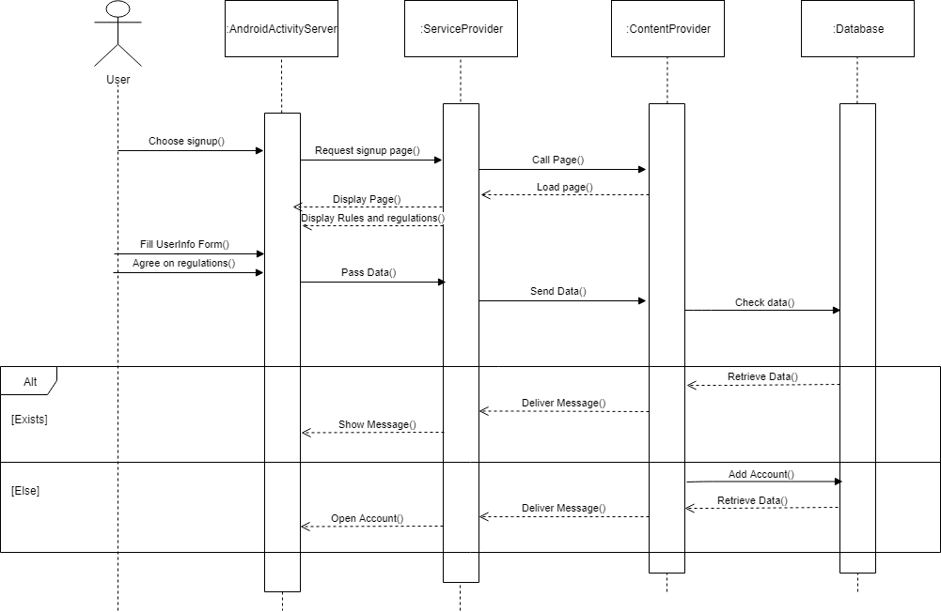

Figure 29:Sign Up sequence Diagram

### 3.3.6 Take picture.

This sequence shows how user can take picture of the place, the classes involved in this function are Android Activity Server which is the UI, the Service Server handle background processing associated with an application, the Content Provider which handle data and database management issues, and the database.

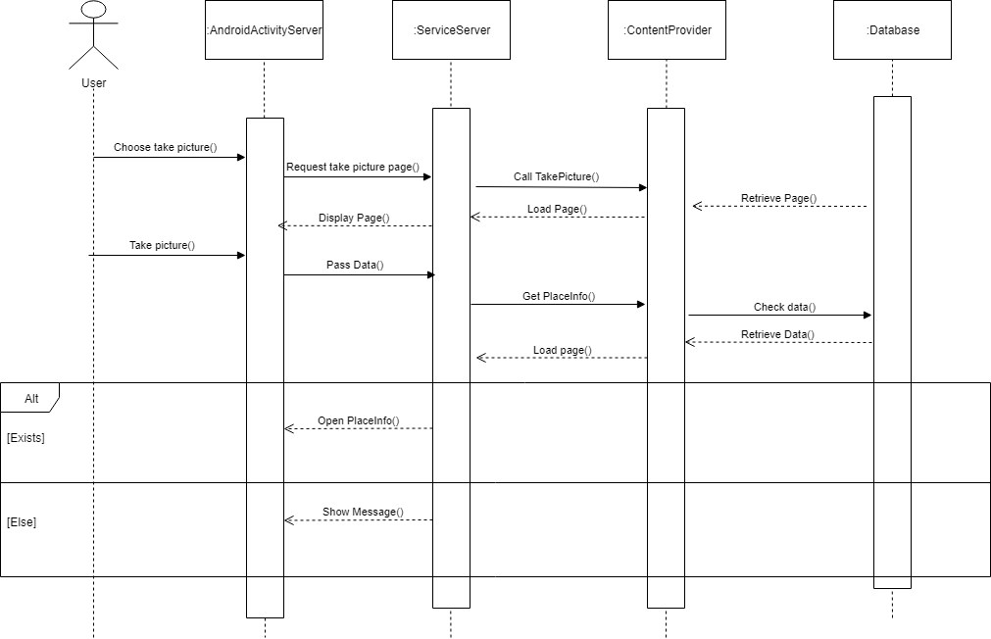

Figure 30:Take picture sequence diagram

### 3.3.7 Update place.

This sequence shows how admin can update a place, the classes involved in this function are Android Activity Server which is the UI, the Service Server handle background processing associated with an application, the Content Provider which handle data and database management issues, and the database.

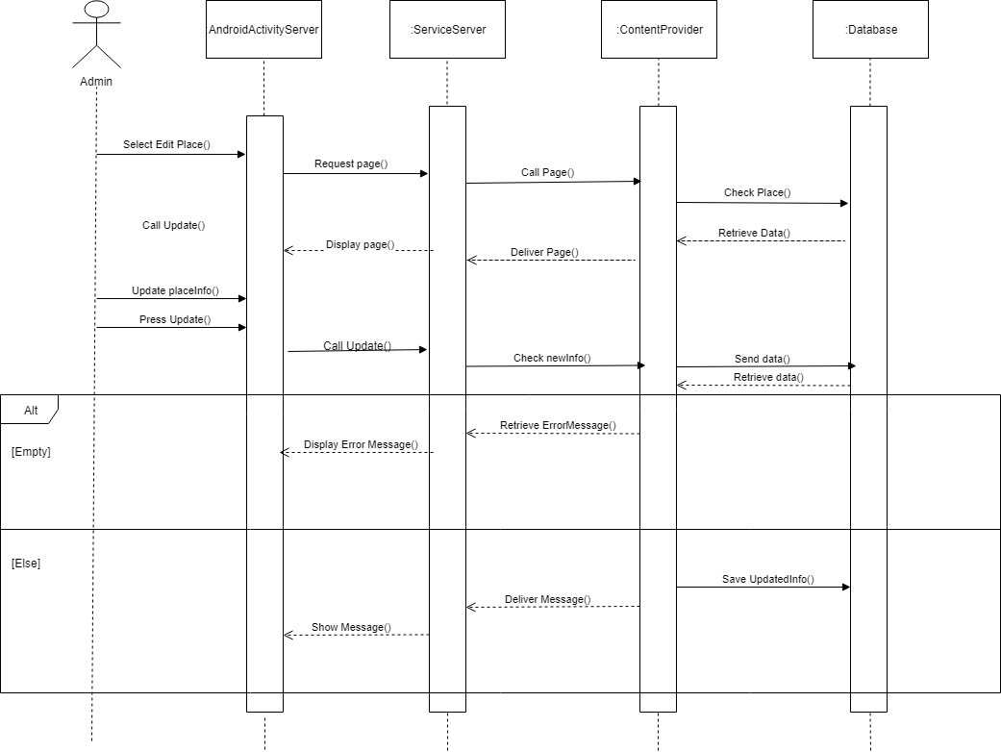

Figure 31:Update place sequence Diagram

## 3.4 State Chart Diagram

State charts diagram of our system.

### 3.4.1 Place Info State chart

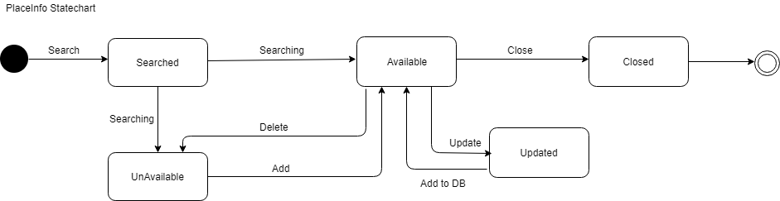

Figure 32:Place Info State chart

### 3.4.2 Account state chart.

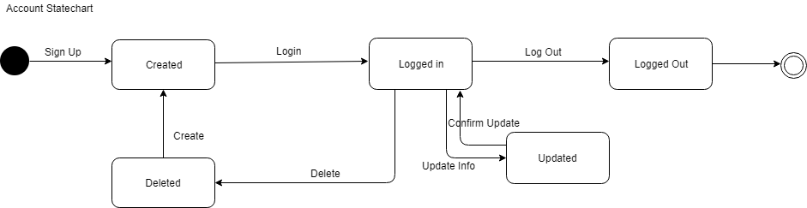

Figure 33:Account state chart

### 3.4.3 Picture state chart.

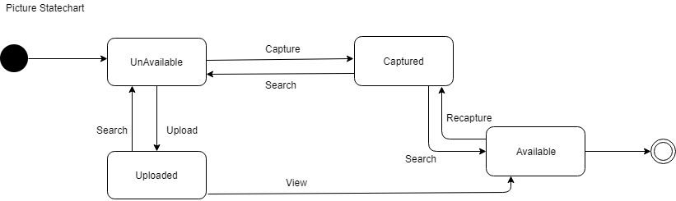

Figure 34:Picture searching state chart

### C:\Users\walaa\Downloads\Untitled Diagram (52).png3.4.4 Rate state chart.

Figure 35:Rate state chart

## 3.5 Design Class Diagram:

Design Class Diagram: Shows all classes in our system, which are User, Admin, Place, Picture, Location, Rate, Tourist Account, and Direction.

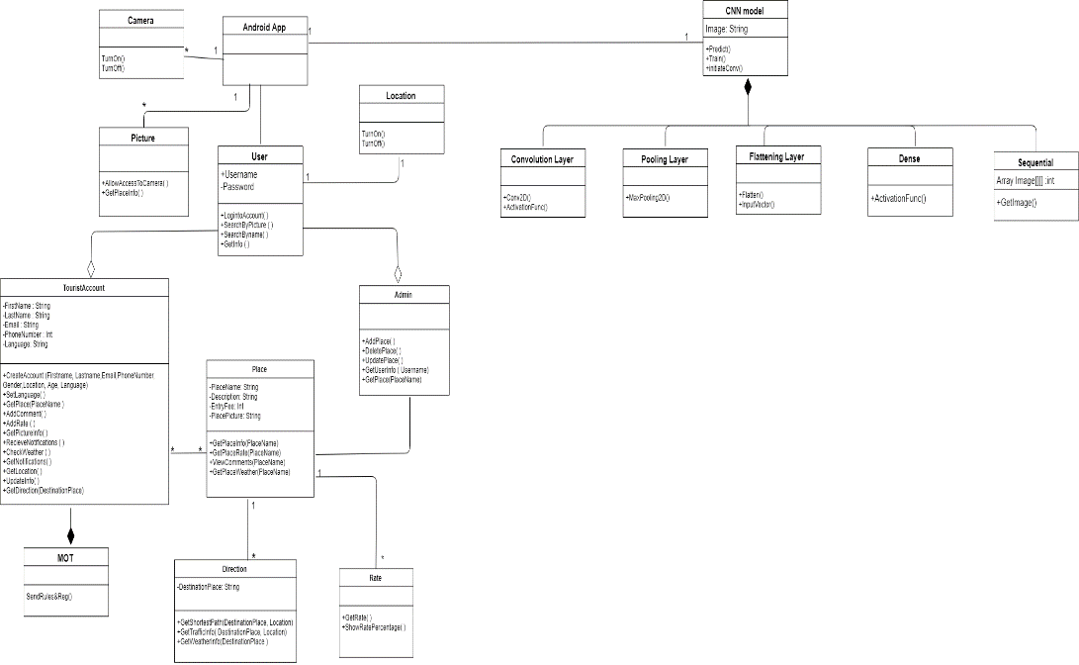

Figure 36: Design class diagram

## 3.6 Components Diagram:

Shows how components interact in our system.

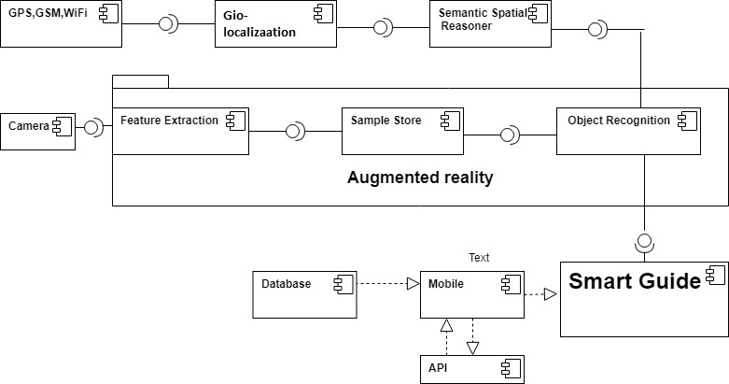

Figure 37: Component Diagram

## 3.7 Deployment Diagram.

Deployment diagram contains the following devices: SQL Server 2012 which contains the main database of our system, Android device where our application will take a part in. and an application server. Mobile Application (Communicate with WEB API using HTTP protocol).

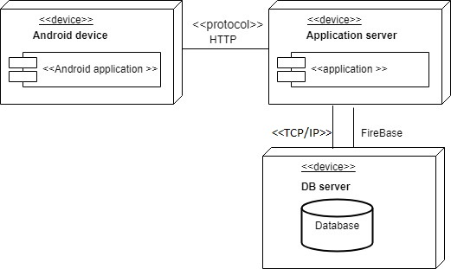

Figure 38:Deployment Diagram

## 3.8 Output & Input Design (Screens):

### 3.8.1 Login

The following screen shows the main screen including the inputs that should be entered by the user (Username, Password) to login to his account. If the user doesn’t have an account, the user should click on (Sign up) to get an account.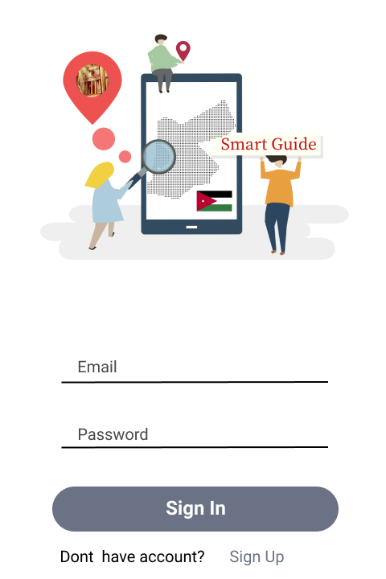

Figure 39:Login Screen

### 3.8.2 Sign up

After clicking on (Sign up) the following page is shown with the fields that should be filled to create an account on the app.

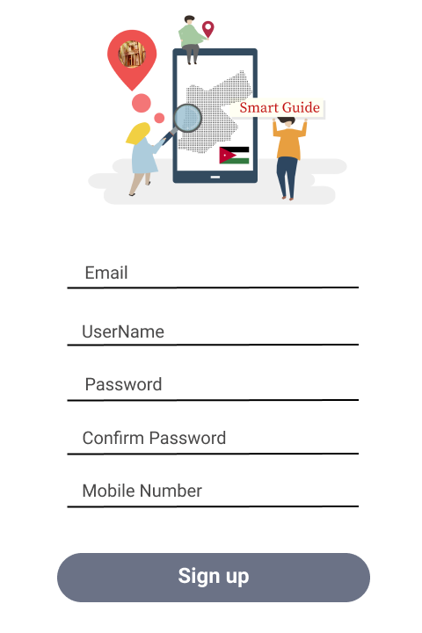

Figure 40:Sign Up screen

### 3.8.3 Picture searching

The user can either search for the place by clicking on (Upload) and uploading a picture of the place or by clicking on (take photo) and take an instant photo of the place or by clicking on (search for the place) and write the place’s name.

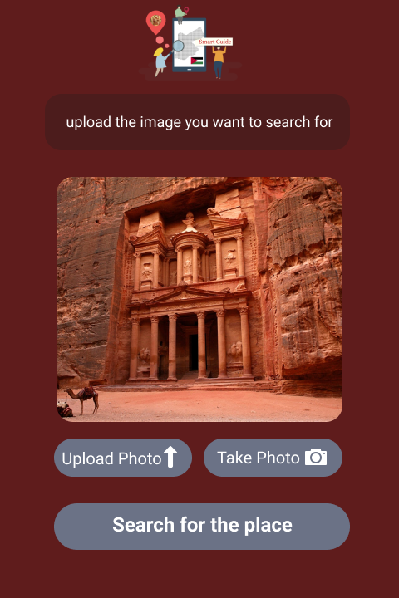

Figure 41:Picture Searching screen

### 3.8.4 Menu view

Once the admin enters his account the following screen is displayed which allows the admin to either delete, update and add a new place.

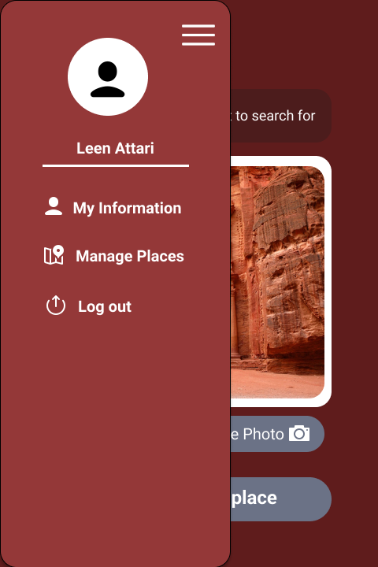

Figure 42:Menu View Screen

### 3.8.5 Output screen

Once the user searches for the place by clicking on either upload, take a photo, or search for a place a description of the place with the weather condition is displayed. 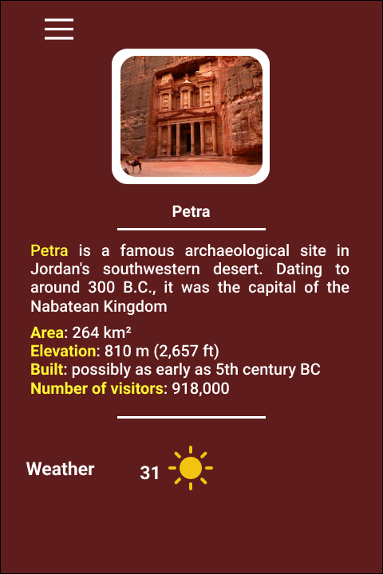

Figure 43:output screen

### 3.8.6 Admin interface (update, delete, add place).

Figure 44:admin interface screen

Once manage places is clicked the following screen is shown which allows the admin to update on existing places or to delete them.

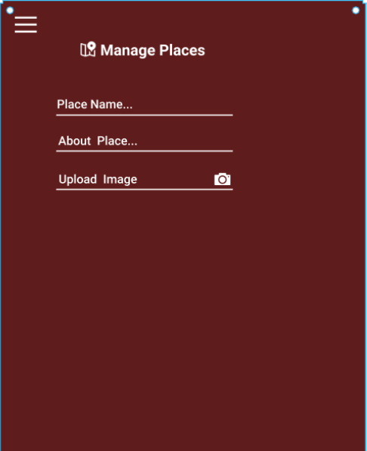

When clicked on (add new place) at the bottom of the previous screen the following page is displayed which allows the admin to add a new place by filling in the fields.

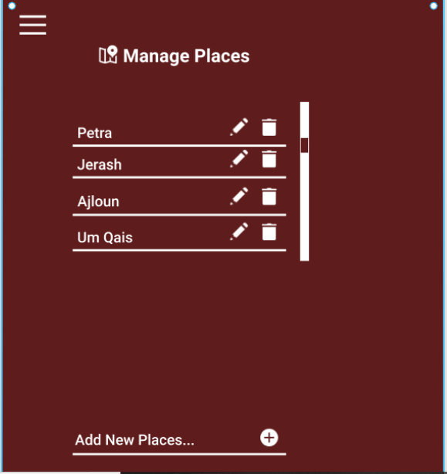

Figure 45:manage places screen

# Chapter Four

# Implementations and testing

## 4. Implementation and Testing

## 4.1 Database Mapping (Schema Diagram):

**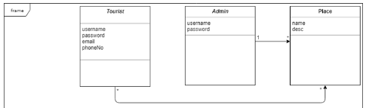**

Figure 46: Database Mapping

**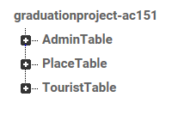**

Figure 47: Database tables

## 4.2 Tables Descriptions:

**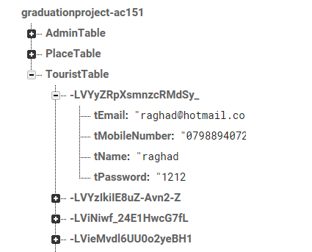**

Figure 48: Tourist Table

Tourist table which identifies the information of tourist: username, password, email, phone number (For Registration or for creating account).

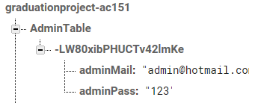

Figure 49: Admin Table

Admin table which identifies the admin’s username and password (for login into the system).

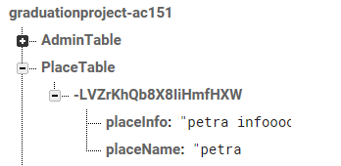

Figure 50: Place Table

Place table which identifies the information of the place: name, description (description of the place such as: location, weather).

## 4.3 Architecture/technology Description:

The system consists of an android application which works as a front end and a CNN model which works as a back-end.

In the beginning our architecture of the system depends on different tiers. At first, we have the android project where it consists of four main layers as the following:

* Activities
* Services
* Broadcast receivers
* Content providers

In addition to that the website is connected to the firebase database where only the content provider can communicate with the DB.

Moreover, we have an application API (activities) that provide services for mobile application through providing a communication to the database of the system.

figure below provides more explanation about our android application system architecture:

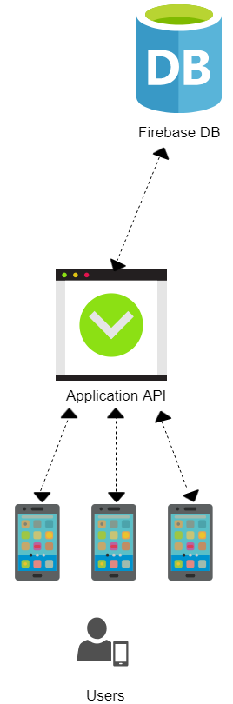

Figure 51:System Architecture

As for the technologies that are used in in our project are described as the following:

At first we have MVC framework which stands for Model View Controller, where the view contains all commands that are related to interface. In addition to all the logic needed to arrange the data displayed to the user. The model consists of all the data that we want to display to the user where we don’t have to return all the elements to the user, therefore it gives the ability to control all what we want to display.

The model consists of all the data that we want to display to the user where we don’t have to return all the elements to the user, where it gives the ability to control all what we want to display to users.

Using the android studio we were able to build our application efficiently with an ease of use interface.

We have worked With [Firebase Authentication](https://firebase.google.com/docs/auth/?utm_campaign=Firebase_featureoverview_education_auth_en_06-22-16&utm_source=Firebase&utm_medium=blog), which helped us outsource our entire authentication system to Firebase so that you can concentrate on building great features for our app. Firebase Authentication makes it easier to get users to sign-in without having to understand the complexities behind implementing our own authentication system. It offers a straightforward getting started experience, optional UX components designed to minimize user friction, and is built on open standards and backed by Google infrastructure. This makes the application more secure.

The SDK tools helped us in connecting the firebase with the android studio.

Secondly, the CNN model which worked in our application as a back-end. We have developed a keras model that serves the application’s main function which is the image search property.

The CNN model was built using python two libraries (Keras and tensorflow). The model consists of two main components which is the data preprocessing and the fully connected ANN.

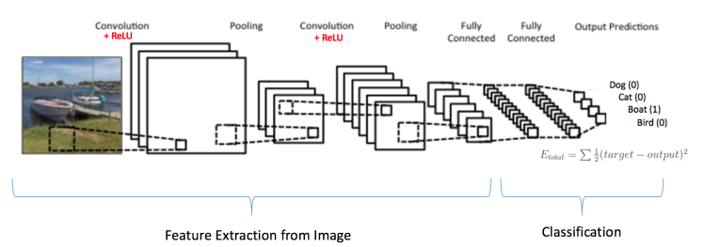

Figure 52: CNN Components Diagram

The data preprocessing contains two convolutional layers, two pooling layers, and one flattening layer. These layers were constructed and ordered as following:

At first, the first Convolutional layer which was ordered using the Conv2D class imported from keras.layers package. It will receive colored images of size 64x64 and produce 32 feature maps using a 3x3 convolution filter and the “ReLU” activation function which is used to increase non-linearity.

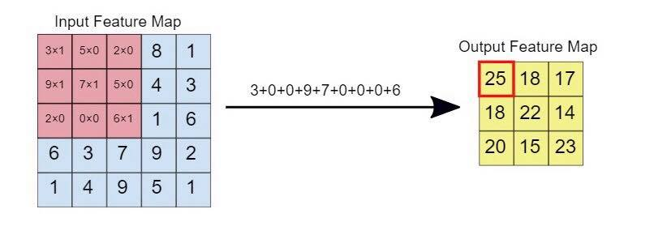Figure 53: Convolution Layer

Secondly, the pooling layer which was ordered using the MaxPooling2D class imported from keras.layers package. It will receive the featured maps produced from previous convolution layer and perform the max pooling function which is used by 2x2 matrix. The first pooling layer is followed next then by the same previous steps (Convolution and pooling).

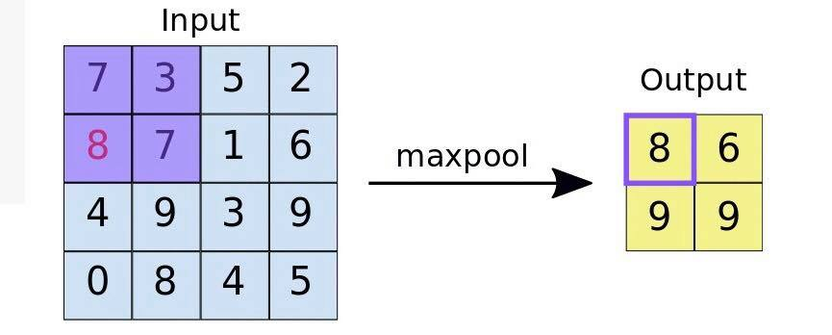

Figure 54:Pooling layer

Finally, the last layer of the data preprocessing flattening which takes the each pooled map and flattens it into one vector that contains all pooled maps produced previously. The flatten layer serves as an input layer for the fully connected ANN.

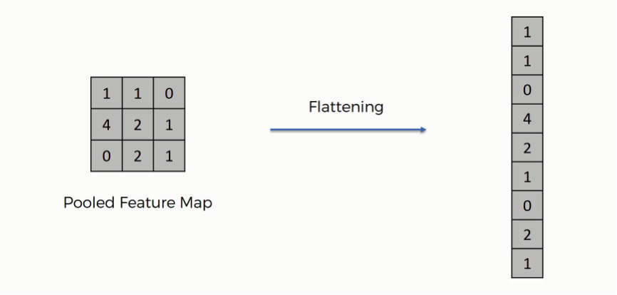

Figure 55:Flattening layer

Then, the ANN which has 3 layers (without the input layer). The first 2 layers serve as hidden layers each layer consists of 64 neurons. The ANN was constructed using the Dense class that was imported from keras.layers package. Both hidden layers used the ReLu activation function. The output layer contains 10 neurons which is the number of classes used, and used the SoftMax activation function.

The model is compiled with the optimizer as “adam” algorithm, “categorical\_crossentropy” as the loss function, and “accuracy” as the only metrics for the model, and is later trained using the “fit\_generator” function with batch size of 32 and 40 epochs to reach the accuracy of 70%.

We have used 300 images referring to 10 classes to train the model. With 40 images that refer to these classes as a test set.

## 4.4 Algorithm for major functions:

### 4.4.1 Add Place Algorithm

01 CLASS AddPlace\_form

02 addplace()

03 Get the place’s name

04 Get the place’s information

05 IF submitted

06 IF place’s name already exists in database THEN

07 Prompt admin for another place’s name

08 Get another place’s name from the admin

09 ELSE

10 IF fields validated THEN

11 Add new place

12 Save the record to database

### 4.4.2 Signup Algorithm

01 CLASS Signup \_form

02 signup()

03 Get the user's name

04 Get the user's password

05 Get the user's email

06 Get the user's mobile number

07 IF submitted

08 IF email already exists in database THEN

09 Prompt admin for another email

10 Get another email from the user

11 ELSE

12 IF fields validated THEN

13 Add new user

14 Save the record to database

### 4.4.3 Login Algorithm

01 CLASS Login\_form

02 Valid()

03 Get the user's email

04 Get the user's password

05 IF submitted

06 IF email-exists in database THEN

07 Logged in (Display the user's profile)

08 ELSE

09 IF email is not exists in database THEN

10 Invalid (email or password) OR create a new account

### 4.4.4 Search for place(Text) Algorithm

01 CLASS Searchforplace \_form

02 result()

03 Get the place’s name

04 IF submitted

05 IF place’s name not exists in database THEN

06 Prompt user for another place’s name

07 Get another place’s name from the user

08 ELSE

09 IF fields validated THEN

10 Display the place’s Information

### 4.4.5 Search for place(Image) Algorithm

01 CLASS SearchforplaceImage \_form

02 search()

03 Get the place’s photo

04 IF submitted

05 IF place’s photo not exists in database THEN

06 Prompt user for another place’s photo

07 Get another place’s photo from the user

08 ELSE

09 IF fields validated THEN

10 Display the place’s Information

### 4.4.6 Update Place Algorithm

01 CLASS Update\_form

02 doit()

03 Get the place’s name

04 IF place’s name already exists in database THEN

05 Prompt admin for the new place’s info

06 Get the new place’s info from the admin

07 Save the new updated info to database.

08 ELSE

09 IF place’s name not exists in database THEN

10 Print an error message.

### 4.4.7 Delete Place Algorithm

01 CLASS Delete\_form

02 deleting ()

03 Get the place’s name

04 IF place’s name already exists in database THEN

05 Delete the Record from database.

06 ELSE

07 IF place’s name not exists in database THEN

08 Print an error message.

## 4.5 Sample code for main functions:

### 4.5.1 Login Function

**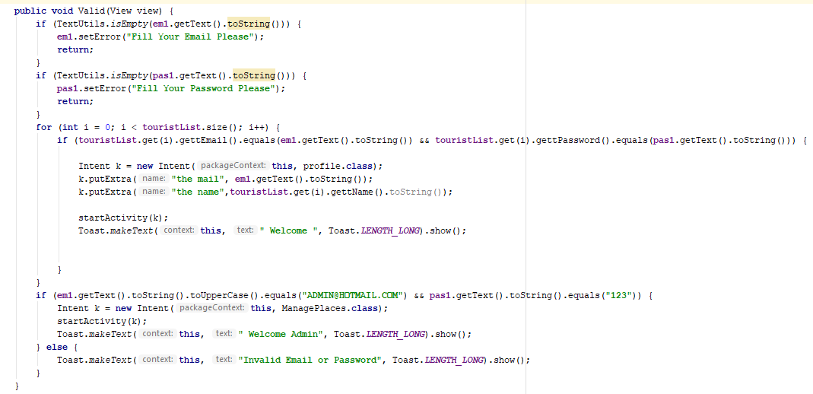**

Figure 56:Login function

4.5.2 Signup Function**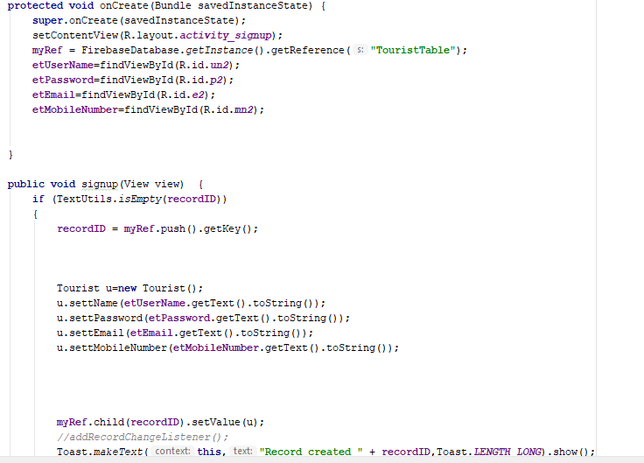**

Figure 57:Sign Up

4.5.3 Add Place Function**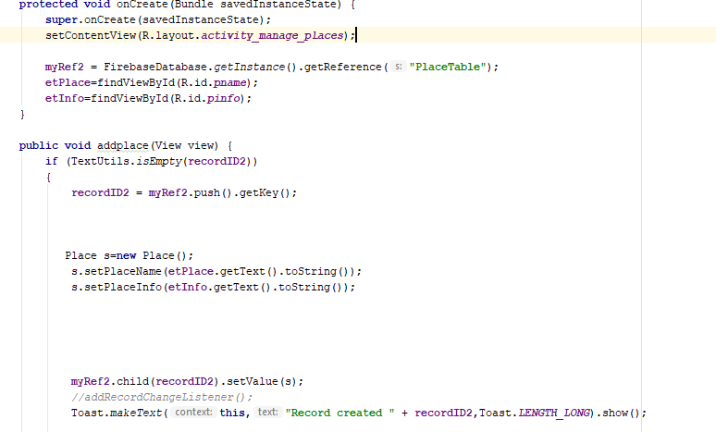**

Figure 58:Add place

### 4.5.4 Update Place Function

**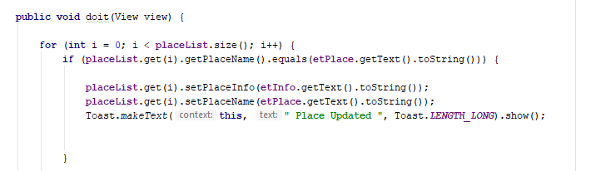**

Figure 59:Update place

### 4.5.5 Delete Place Function

**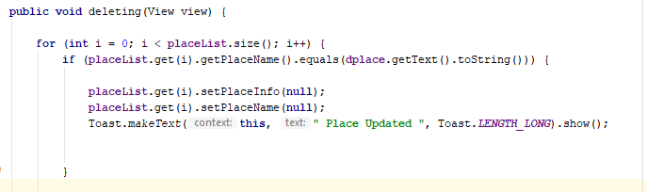**

Figure 60:Delete Place

### 4.5.6 Search (TEXT) Function

**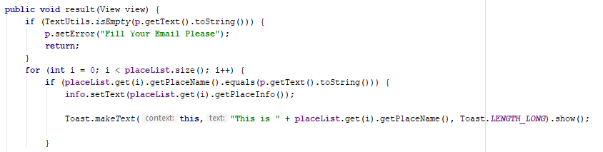**

Figure 61:Search for place by text

### 4.5.7 Search (Image) Function

**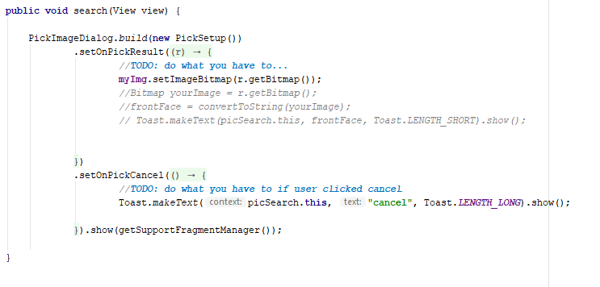**

Figure 62:Search for place by image(android)

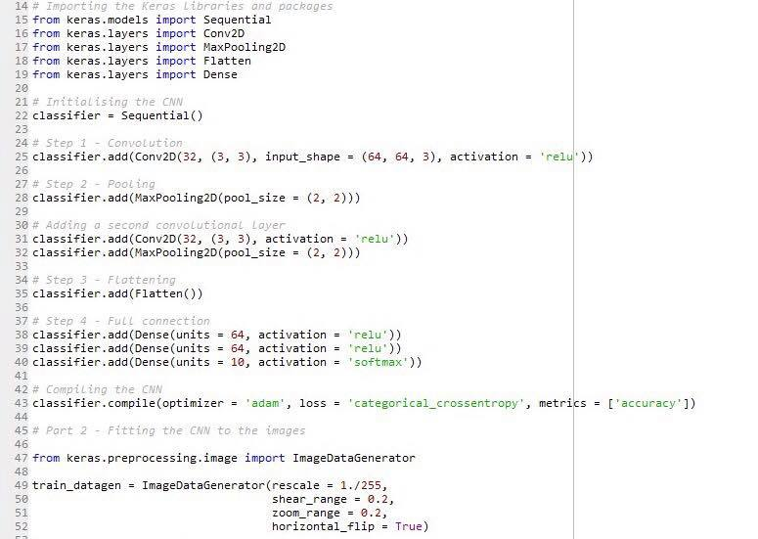

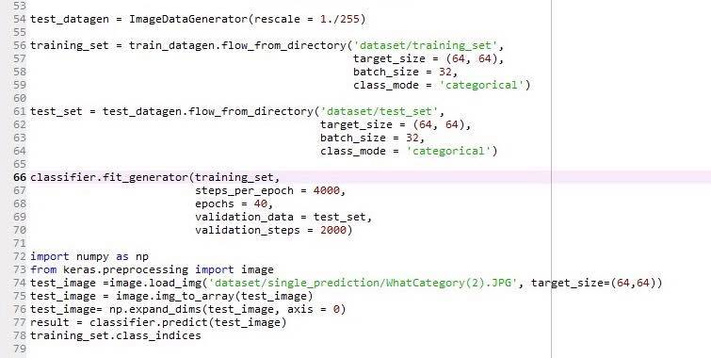

Figure 63:Search for place by image(Python)

## 4.6Functional test cases:

### 4.6.1 Login function:

|  |  |  |  |  |
| --- | --- | --- | --- | --- |
| Test case ID | Inputs | Expected output | Actual output | Fail/Pass |
| 1 | Email=””, Password=”112233” | Error Message | Error Message | Pass |
| 2 | Email=”[Walaahussam11@gmail.com](mailto:Walaahussam11@gmail.com)” , Password=”” | Error Message | Error Message | Pass |
| 3 | Email=”Walaahussam” ,  Password=”112233” | Error Message | Error Message | Pass |
| 4 | Email=”” , Password=”” | Error Message | Error Message | Pass |
| 5 | Email=”Admin@Hotmail.com” , Password=”123” | Access Admin Page | Access Admin Page | Pass |
| 6 | Email=”[Walaahussam11@gmail.com](mailto:Walaahussam11@gmail.com)” , Password=”112233” | Access User Page | Access User Page | Pass |
| 7 | Email=”Admin@Hotmail.com” , Password=”1233” | Error Message | Error Message | Pass |
| 8 | Email=”[Walaahussam11@gmail.com](mailto:Walaahussam11@gmail.com)” , Password=”11223344” | Error Message | Error Message | Pass |

Table 9:Login Function test case

### 4.6.2 Sign up function:

|  |  |  |  |  |
| --- | --- | --- | --- | --- |
| Test case ID | Inputs | Expected output | Actual output | Fail/Pass |
| 1 | Email=””, Password=””, Username=”” ,  Mobile No.=”” | Error Message | Error Message | Pass |
| 2 | Email=”[Walaahussam11@gmail.com](mailto:Walaahussam11@gmail.com)” , Password=”112233”, Username=”Walaahussam” ,  Mobile No.=”07999999” | Error Message | Error Message | Pass |
| 3 | Email=”RaghadRabah” ,  Password=”116998”, Username=”Raghad Rabah” , Mobile No.=”0788888888” | Error Message | Error Message | Pass |
| 4 | Email=”Admin@Hotmail.com” , Password=”123” Username=”Admin” , Mobile No.=”0798833221” | Error Message | Error Message | Pass |
| 5 | Email=” RaghadRabah@gmail.com” , Password=”” , Username=”” ,  Mobile No.=”” | Error Message | Error Message | Pass |
| 6 | Email=”” , Password=”11223344” , Username=”Raghad Rabah” ,  Mobile No.=”078888888” | Error Message | Error Message | Pass |
| 7 | Email=” RaghadRabah@gmail.com” , Password=”” , Username=”Raghad Rabah” ,  Mobile No.=” 078888888” | Error Message | Error Message | Pass |
| 8 | Email=” RaghadRabah@gmail.com” , Password=”11223344” , Username=”Raghad Rabah” , Mobile No.=”” | Error Message | Error Message | Pass |
| 9 | Email=” RaghadRabah@gmail.com” , Password=”11223344” , Username=”” ,  Mobile No.=” 078888888” | Error Message | Error Message | Pass |
| 10 | Email=”RaghadRabah@gmail.com” , Password=”116998” , Username=”Raghad Rabah” , Mobile No.=”0788888888” | Access user profile | Access user profile | Pass |

Table 10:Sign up Function test case

### 4.6.3 Add Places:

|  |  |  |  |  |
| --- | --- | --- | --- | --- |
| Test case ID | Inputs | Expected output | Actual output | Fail/Pass |
| 1 | Place Name=”” , Place Info=”” | Error Message | Error Message | Pass |
| 2 | Place Name=”Treasury Petra ” , Place Info=”…..” | Error Message | Error Message | Pass |
| 3 | Place Name=”Umm Alrasas” , Place Info=”” | Error Message | Error Message | Pass |
| 4 | Place Name=”” , Place Info=”….” | Error Message | Error Message | Pass |
| 5 | Place Name=”Umm Alrasas” , Place Info=”…” | Place is Added | Place is Added | Pass |

Table 11:Add Places function test case

### 4.6.4 Delete Places:

|  |  |  |  |  |
| --- | --- | --- | --- | --- |
| Test case ID | Inputs | Expected output | Actual output | Fail/Pass |
| 1 | Place Name=”” | Error Message | Error Message | Pass |
| 2 | Place Name=”Treasury Petra ” | Place Deleted | Place Deleted | Pass |
| 3 | Place Name=”dhbslcdjcn” | Error Message | Error Message | Pass |

Table 12:Delete places function test case

### 4.6.5 Update Places:

|  |  |  |  |  |
| --- | --- | --- | --- | --- |
| Test case ID | Inputs | Expected output | Actual output | Fail/Pass |
| 1 | Place Name=”” , Place Info=”” | Error Message | Error Message | Pass |
| 2 | Place Name=”Treasury Petra ” , Place Info=”…..” | Place Updated | Place Updated | Pass |
| 3 | Place Name=”Umm Alrasas” , Place Info=”” | Error Message | Error Message | Pass |
| 4 | Place Name=”Umm Alrasas” , Place Info=”” | Error Message | Error Message | Pass |

Table 13:Update places function test case

### 4.6.6 Search Place (Text):

|  |  |  |  |  |
| --- | --- | --- | --- | --- |
| Test case ID | Inputs | Expected output | Actual output | Fail/Pass |
| 1 | Place Name=”” | Error Message | Error Message | Pass |
| 2 | Place Name=”Treasury Petra ” | Access Place Page | Access Place Page | Pass |
| 3 | Place Name=”gdvkafchdb” | Error Message | Error Message | Pass |

Table 14:Search places by text test case

### 4.6.7 Search Place (image):

|  |  |  |  |  |
| --- | --- | --- | --- | --- |
| Test case ID | Inputs | Expected output | Actual output | Fail/Pass |
| 1 | Place Image=”” | Error Message | Error Message | Pass |
| 2 | Place Image=”C:\Users\walaa\Desktop\project\dataset\test_set\Treasury_Petra\Treasury_Petra(4).jpg “ | Access Place Page | Access Place Page | Pass |

Table 15:Search place by image function test case

# Chapter Five

# Conclusion and future improvements

## 5. Conclusion and Future Improvements

## 5.1 Conclusion:

In conclusion we have designed our system as a mobile application for android platform, the system is available only for Jordan Tourist attraction locations, it shall provide description for places depending on the user’s search (either by image or text) which will help tourists pertain all the information they want to get in addition to the directions to that place and the ratings to it. It shall also allow users to create an account or login into their accounts and update their personal info in the application as well as deleting their accounts. In addition it shall allow users to rate the places that they have visited, and send notifications to users about weather updates . The system is implemented in an easy to use user interface.

## 5.2 Future improvements:

More features will be added to the applications, such as, text-to-voice command as well as adding other languages that the system has(French, Spanish, Etc.). In addition, more places will be added to the system, and it will expand a bit to include all historical places and hotels in Jordan. Also, we will work on notifying users with latest weather updates. We will also, implement the system using IOS programming languages to make this app work on iPhones as well.

# Appendix A Questionnaire analysis results

**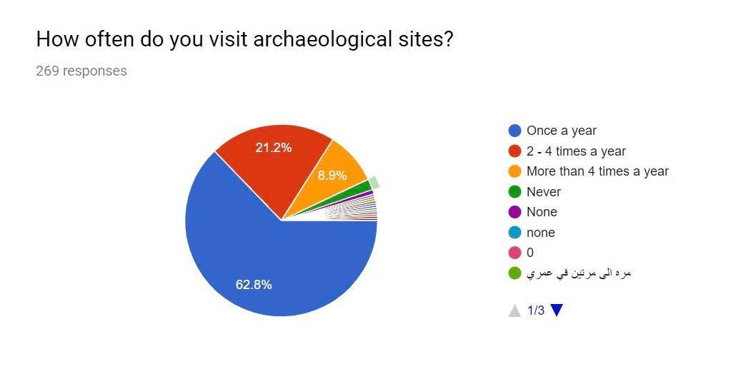**

Figure 64: Questionnaire analysis

**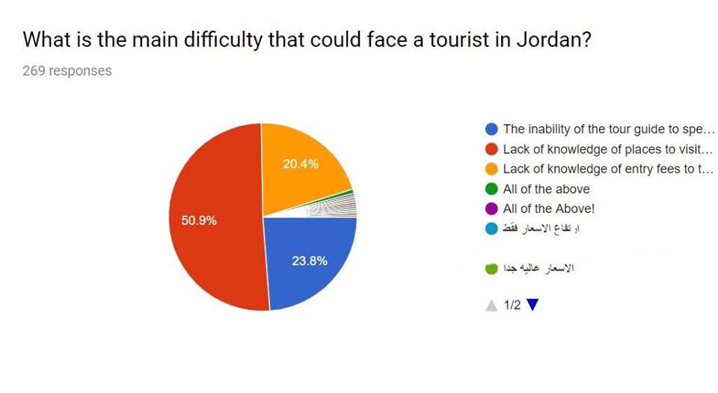**

Figure 65: Questionnaire analysis

**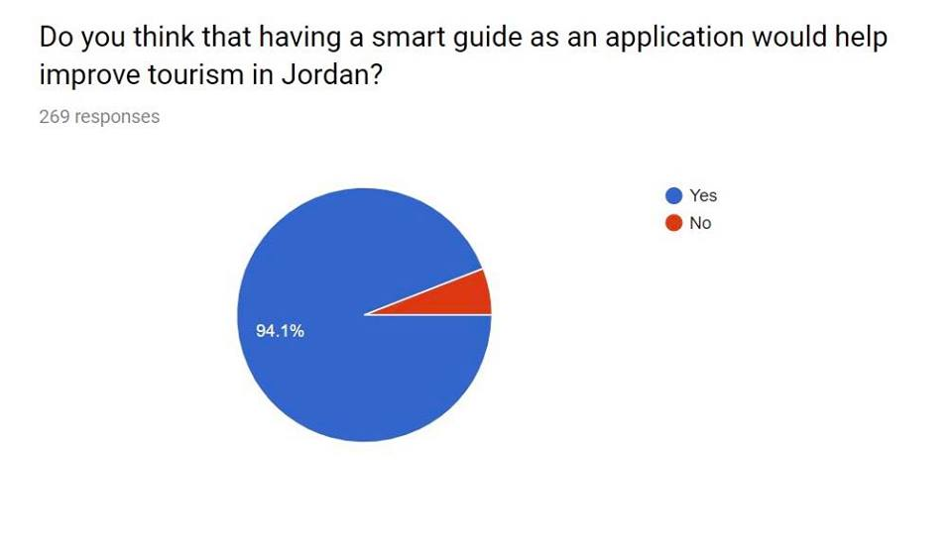**

Figure 66: Questionnaire analysis

**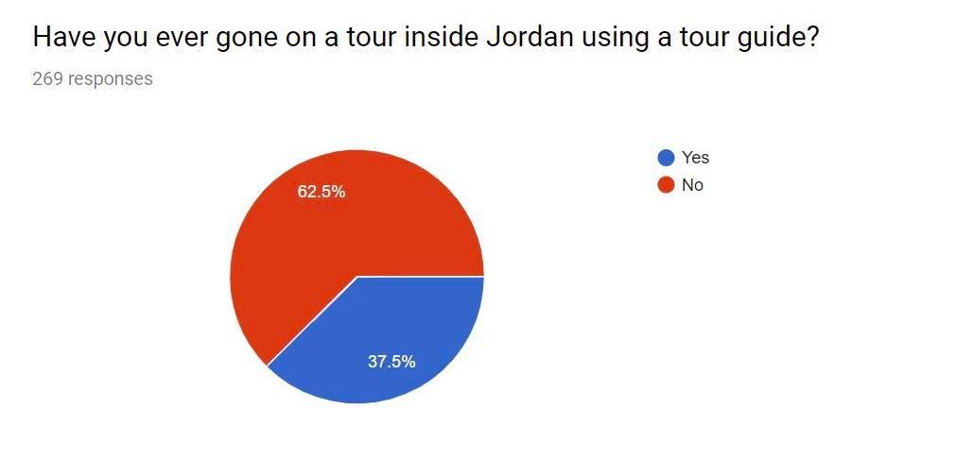**

Figure 67: Questionnaire analysis

**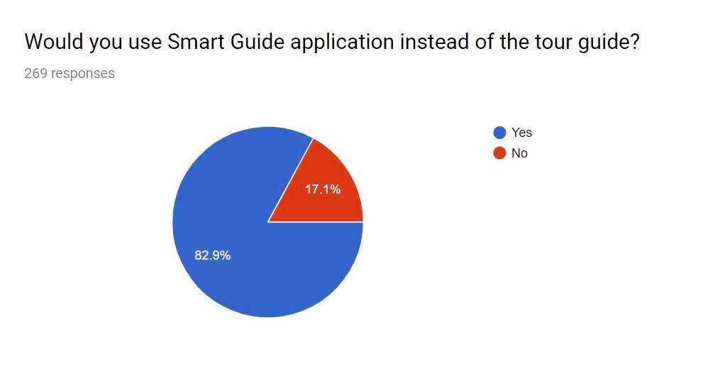**

Figure 68: Questionnaire analysis

# References:

Google play, 2018. Asfar app. [online] Available at: <https://play.google.com/store/apps/details?id=com.everest.asfarapp&hl=en>  
[Accessed 2 November 2018].

Google play, 2015. Field trip [online] Available at:  
<https://play.google.com/store/apps/details?id=com.nianticproject.scout&hl=en>  
[Accessed 2 November 2018].

App store, 2018. Rick Steves Audio Europe ™. [online] Available at: <https://itunes.apple.com/us/app/rick-steves-audio-europe/id414357125?mt=8>  
[Accessed 2 November 2018].

Ahmed Bani Mustafa, Available At: ‘Tourism sector expected to continue recovering in 2018’, The Jordan Tmes Jan 03,2018

[Accessed 8 November 2018].

Albusaidi, H.S.; Udupi, P.K.; Dattana, V. Integrated data analytic tourism dashboard (IDATD). In Proceedings of the 2016 5th International Conference on Reliability, Infocom Technologies and Optimization (Trends and Future Directions) (ICRITO), Noida, India, 7–9 September 2016; Shukla, B., Khatri, S.K., Kapur, P.K., Eds.; Institute of Electrical and Electronics Engineers Inc.: Piscataway, NJ, USA, 2016  
[Accessed 4 November 2018].

Basili, A.; Liguori, W.; Palumbo, F. NFC smart tourist card: Combining mobile and contactless technologies towards a smart tourist experience. In Proceedings of the 2014 IEEE 23rd International WETICE Conference (WETICE), Parma, Italy, 23–25 June 2014; Reddy, S.M., Ed.; IEEE Computer Society: Washington, DC, USA, 2014.  
[Accessed 4 November 2018].

Bhat, S. A., & Shah, M. A. (2014). Diffusion of Internet Technology in the Tourism Sector: An Empirical Study. Journal of Transnational Management, 19(2), 152–164. doi:10.1080/15475778.2014.904674  
[Accessed 4 November 2018].

Gretzel, U.; Koo, C.; Sigala, M.; Xiang, Z. Special issue on smart tourism: Convergence of information technologies, experiences, and theories. Electron. Mark. 2015  
[Accessed 4 November 2018].

Guifang Lin et al. / Procedia Computer Science 131 (2018) 977–984. Available At:

<https://www.sciencedirect.com/science/article/pii/S1877050918306197>

<http://sci-hub.tw/https://www.sciencedirect.com/science/article/pii/S1877050918306197>

[sci-hub.tw/10.1016/j.procs.2018.04.239](https://sci-hub.tw/10.1016/j.procs.2018.04.239)

Lin, G., & Shen, W. (2018). *Research on convolutional neural network based on improved Relu piecewise activation function. Procedia Computer Science, 131, 977984.*doi:10.1016/j.procs.2018.04.239

[Accessed 6 February 2019].

Han, H.; Park, A.; Chung, N.; Lee, K.J. A near field communication adoption and its impact on expo visitors’ behavior. Int. J. Inf. Manag. 2016  
[Accessed 4 November 2018].

Huang, C.D.; Goo, J.; Nam, K.; Yoo, C.W. Smart tourism technologies in travel planning: The role of exploration and exploitation. Inf. Manag. 2017  
[Accessed 4 November 2018].

Kim, S.-E.; Lee, K.Y.; Shin, S.I.; Yang, S.-B. Effects of tourism information quality in social media on destination image formation: The case of sina weibo. Inf. Manag. 2017  
[Accessed 4 November 2018].

Koo, C.; Park, J.; Lee, J.N. Smart tourism: Traveler, business, and organizational perspectives. Inf. Manag.2017  
[Accessed 4 November 2018].

Krinkin, K.; Yudenok, K. Geo-coding in smart environment: Integration principles of smart-M3 and geo2tag. In Internet of Things, Smart Spaces, and Next Generation Networking; Balandin, S., Andreev, S., Koucheryavy, Y. ,Eds.; Springer: Berlin/Heidelberg, Germany, 2013;  
[Accessed 4 November 2018].

Neuhofer, B.; Buhalis, D.; Ladkin, A. Smart technologies for personalized experiences: A case study in the hospitality domain. Electron. Mark. 2015  
[Accessed 4 November 2018].

Peter Tarlow, TOURISM ORIENTED POLICING AND THE TOURISM INDUSTRY, International Journal of Event Management Research Volume 8, Number 1, 2014.  
[Accessed 4 November 2018].  
Teslya, N.; Ponomarev, A. Smart tourism destination support scenario based on human-computer cloud. In Proceedings of the 2016 19th Conference of Open Innovations Association (FRUCT), Jyvaskyla, Finland, 7–11 November 2016; Tyutina, T., Balandin, S., Eds.; IEEE Computer Society: Washington, DC, USA, 2017  
[Accessed 4 November 2018].

The Role of Mobile Technology in Tourism: Patents, Articles, News, and Mobile Tour App Reviews Dongwook Kim 1 and Sungbum Kim 2, \* ID 1 Graduate School of Innovation and Technology Management, Korea Advanced Institute of Science Technology (KAIST), Daejeon 305-701, Korea; heavenk1@kaist.ac.kr 2 2017  
[Accessed 4 November 2018].

Xiang, Z.; Wang, D.; O’Leary, J.T.; Fesenmaier, D.R. Adapting to the internet. J. Travel Res. 2015  
[Accessed 4 November 2018].